Expedition:  Come Fly with Me  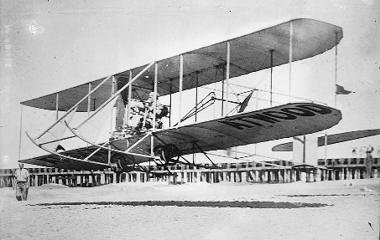 | Overview:  This expedition focuses on geography, history and science.  The overarching theme is ‘flight’, so the children will be exploring the landscapes of the world from a bird’s eye view. We will also be thinking about the flight routes across the globe. The children will have the chance to revisit their geography learning from previous expeditions.  We will also be going back in time to learn about famous inventors of flight machines and explorers who ventured on the first flight expeditions of their time.  Our science focus is birds where the children will learn about this type of animal in depth and have the chance to apply their learning of animals from previous expeditions. | Supporting Texts:  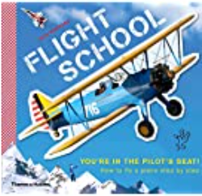  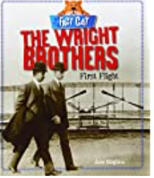  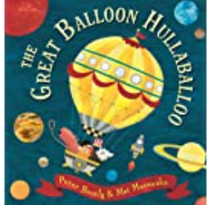  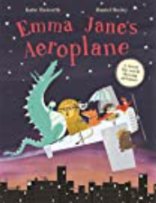  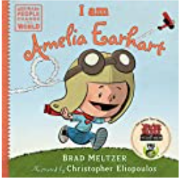  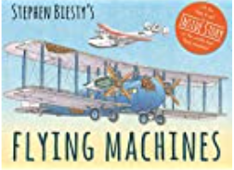  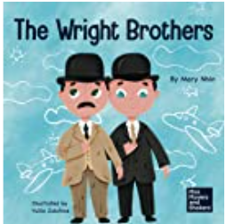  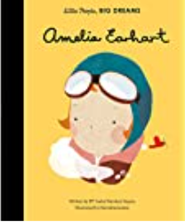  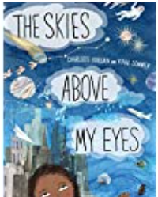  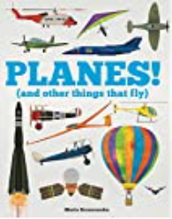  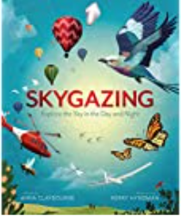  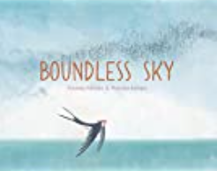  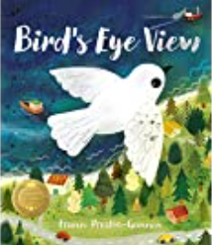  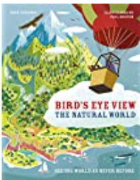  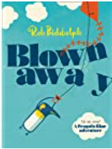  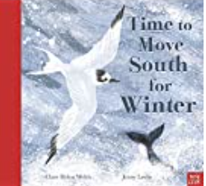
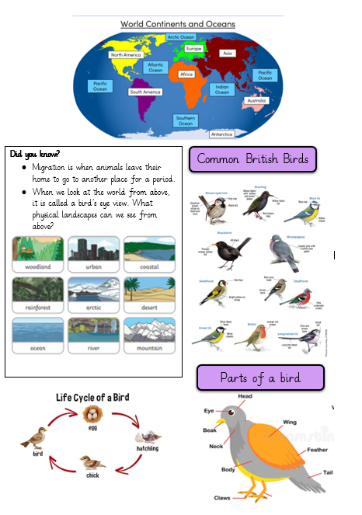
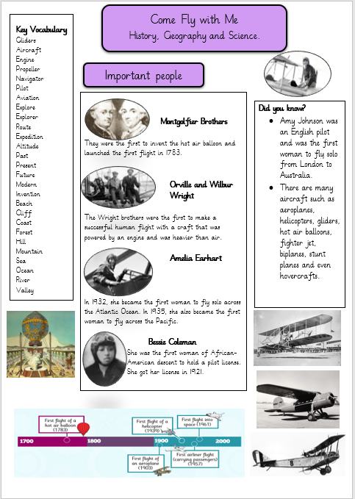
Knowledge:

History/ Geography
Our learning focus will be the history of flight looking at famous inventors and explorers.
Vocabulary:
Gliders, aircraft, engine, propeller, navigator, pilot, aviation, explore, explorer, route, expedition, journey, altitude, past, present, future, modern, invention.

Beach, cliff, coast, forest, hill, mountain, sea, ocean, river, valley.

Key Questions:
Week 1: What are the 7 continents and 5 oceans? Where are they on a map?
Week 2: Why do people fly and where do they go? How do they get there? What routes do they take?
Week 3: What is the environmental impact of flying? What landscapes can we see from a birds eye view?
Week 4: How did people fly before the invention of planes? How do planes fly?
Week 5: Who were the Montgolfier brothers? Who were the Wright Brothers? Who was George Cayley?
Week 6: Who was Amelia Earhart? Who was Bessie Coleman? Who was Amy Johnson?
Week 7: What might the future of flight look like?
Science:
Our learning for this half term will focus on birds, making that link of flight.
Vocabulary:
Birds, herbivore, carnivore, omnivore, consumer, producer, predator, identify, sort, group, classify, life-cycle.

Key Questions:
Week 1: What creatures can fly? How do they fly?
Week 2: What are the parts of a bird? What are the names of common birds?
Week 3: Where do birds live? How are they built/ suited to survive their habitat?
Week 4: What do birds need to survive? How do birds obtain food?
Week 5: What is the life cycle of a bird?
Week 6: What are the parts of a feather? Why are they important?
Week 7: Expedition revisit.

Art/ DT:

We will be:
- Learning papier Mache and weaving techniques to create our own miniature hot air balloons.
RE:
‘How should we care for the world and for others, and why does it matter?’

