Expedition:  Seaside Holidays Past and Present  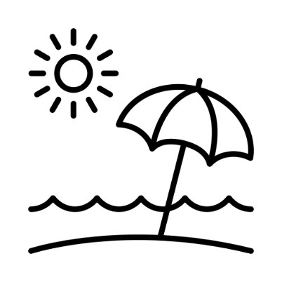 | Overview:  This expedition will guide children on a historical journey about how the seaside holiday has changed from Victorian times right through to modern day. We will learn about the development in transport and how it has enabled more people to visit coastal towns.  Our geography learning will teach us the human and physical features of the seaside and hone in on our own costal living in Cornwall. | Supporting Texts:  Here is a selection of the texts we will be using to support our learning.  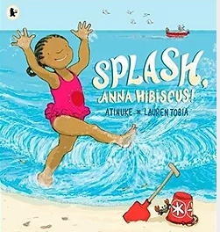  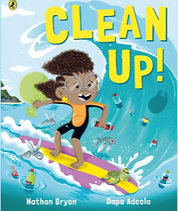  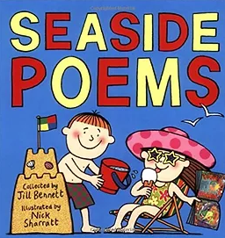  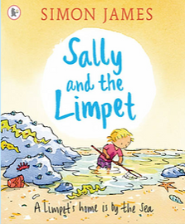  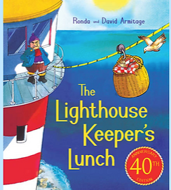  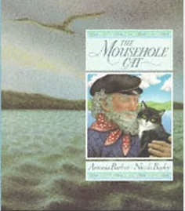  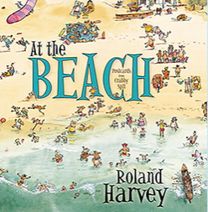  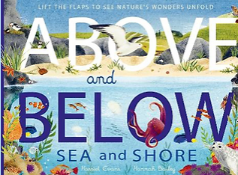
Knowledge:
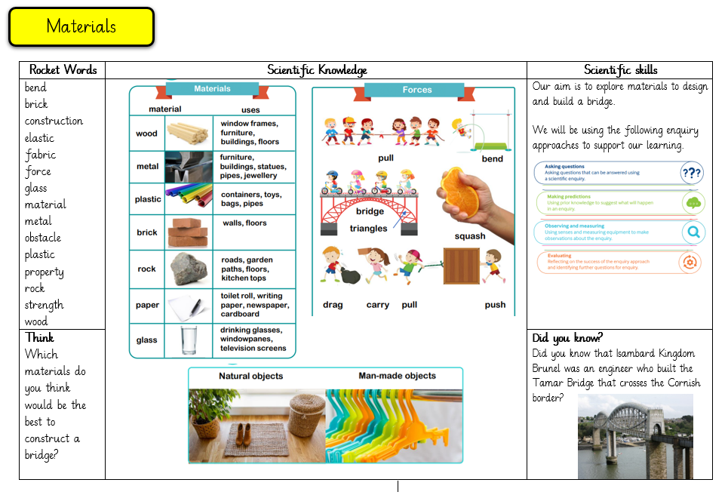
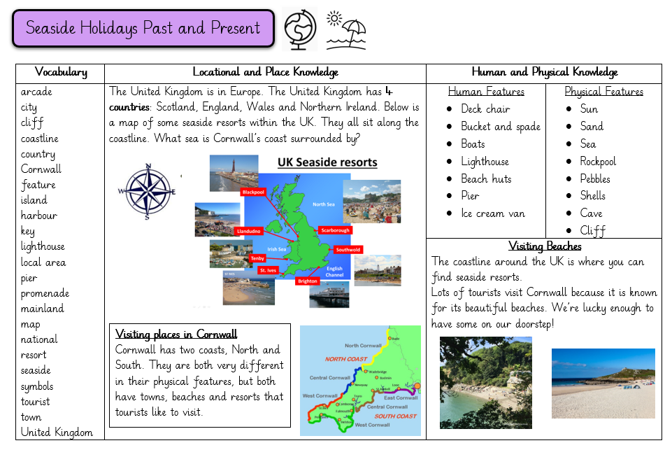
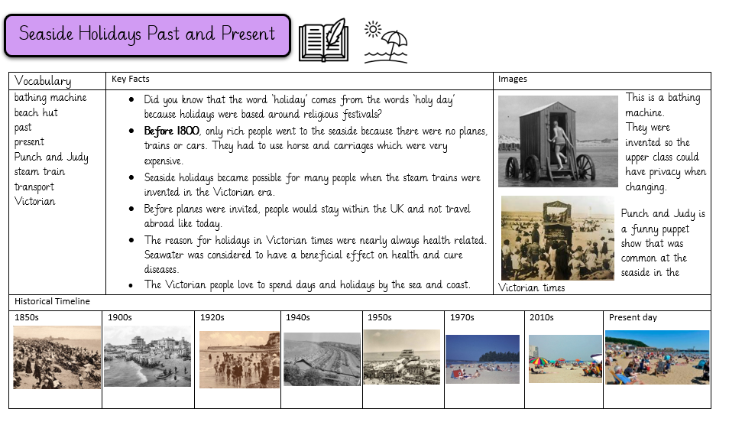

History
Vocabulary:

bathing machine, change, continuity, beach hut, past, present, Punch and Judy, steam train, transport, Victorian

Key Questions:
Week 1: What were seaside holidays like in the past? How did Victorians spend their leisure time?
Week 2: How did people travel to the seaside?
Week 3: Who invented the steam train/ railway?
Week 4: What was the Stephenson’s rocket?
Week 5: What was the flying Scotsman?
Week 6: How has rail travel had an impact on coastal towns?
Week 7: How have seaside towns changed?

Geography
Vocabulary:

Arcade, city, cliff, coastline, country, Cornwall, feature, island, harbour, key, lighthouse, local area, pier, promenade, mainland, map, national, resort, seaside, symbols, tourist, town, United Kingdom

Key Questions:
Week 1: What are the four countries that make up the United Kingdom? What are the surrounding seas/ocean?
Week 2: What are the main seaside resorts in the United Kingdom?
Week 3: What are the geographical features that you would find at a seaside?
Week 4: What is Cornwall like to go on holiday?
Week 5: How would you compare Cornwall’s seaside locations to others in the country?
Week 6: How would you describe the coastline of Cornwall? How do the north and south coasts differ?
Week 7: How are beaches created? How do tides work?

Science:
Our learning for this half term will focus on selecting the right materials to construct a bridge.
Vocabulary:

Bend, brick, construction, elastic, fabric, force, glass, material, metal, obstacle, plastic, property, rock, strength, wood
Scientific skills:

Key Questions:
Week 1: What are the typical weather patterns in summer? (setting up a daily weather observation station)
Week 2: What are materials and what are their uses?
Week 3: What materials are objects made from?
Week 4: What are the properties of different materials?
Week 5: How can we select the right materials to build a bridge?
Week 6: How can we build and test our bridge structures? Who was Isambard Kingdom Brunel?
Week 7: What habitats can we find at a beach? (beach visit)

English:
We will be learning how to write a set of instructions and a narrative: setting description.

Maths:

Our areas of focus are time, statistics and position and direction.
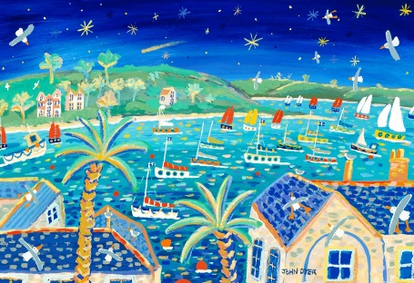
Art:

Our artistic inspiration will be John Dyer.

We will focus on the key concepts of form, colour and texture.

RE:
‘How should we care for the world and for others and why should it matter?’

