Expedition:  Mawnan and the D-Day Landings.  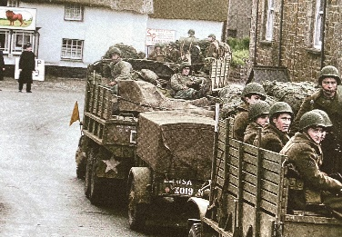 | Overview:  This expedition is a local history study where the children will be learning about Mawnan’s role in the WW2 D-Day landings. We will begin our learning journey by gaining background knowledge as to why WW2 began before learning in depth about what D-Day was and the role Mawnan took during this time. | Supporting Texts:  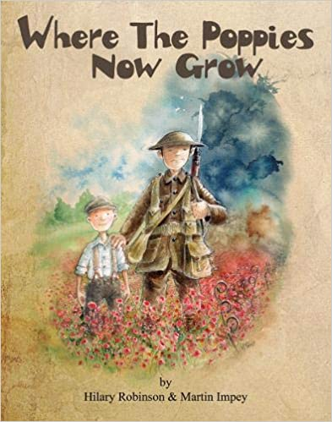  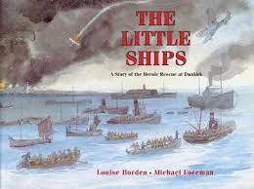  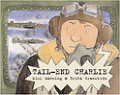
Knowledge:

Science:
Plants
Vocabulary:
Grow, seeds, bulb, roots, stem, leaves, flowers, trunk, tree, garden plant, wild plant, deciduous tree, evergreen tree, dandelion, daisy, rose, pansy, sunflower, maple, oak.

Key Questions:
Week 1: What can we see when we observe the plants around us?
Week 2: How do seeds disperse?
Week 3: What are the parts of a flower?
Week 4: What are the names of some garden and wild plants?
Week 5: What are the different types of trees?
Week 6: What are the similarities and differences of plants?

Geography/ History:
Vocabulary:
D-Day, landings, troops, forces, tank tracks, allies, invasion, army, fortifications, Normandy, remembrance, veterans, Germany, Britain, Canada, France, America, win, defeat, liberate, rationing.

Key Questions:
Week 1: Why did World War Two begin? Which countries took part?
Week 2: What were the D-Day landings?
Week 3: Who came to Mawnan and where did they come from?
Week 4: How did people in Mawnan prepare for the D-Day landings? What was the role of Trebah?
Week 5: What was life like for the Americans who came to Mawnan?
Week 6: What was/ is the lasting impact of the D-Day landings in Mawnan?
Art/ DT:

We will be:
- Researching, designing and making WW2 posters.
- Looking at wartime bunting and creating our own.

RE:

‘What does it mean to belong to a faith community?’

