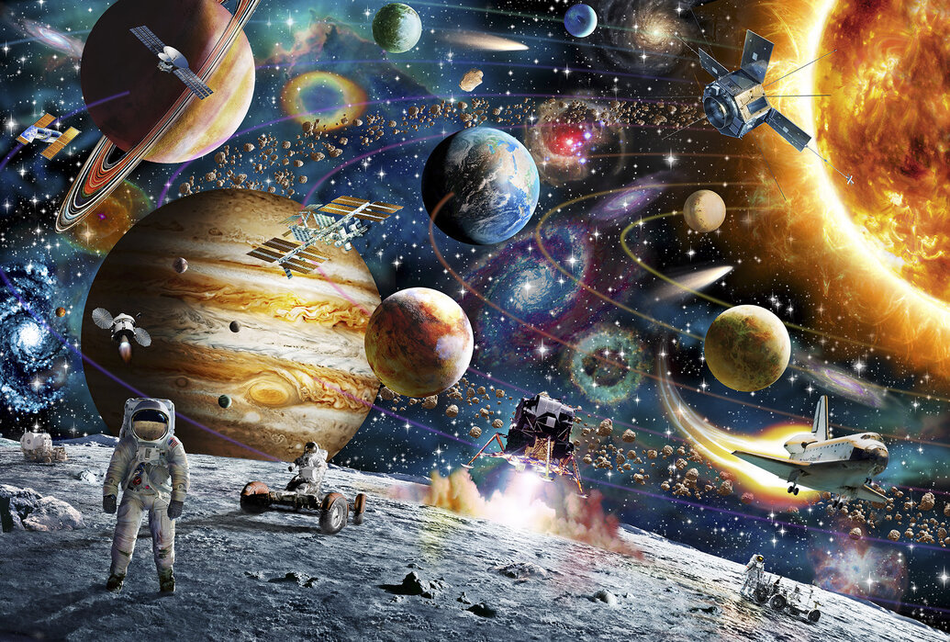
Science Materials – Alfresco Learning.
Week 1: What is an object and what is the material?
Week 2: What are the physical properties of everyday materials?
Week 3: How can we group materials by their properties?
Week 4: Which materials are the best at insulation?
Week 5: How do we know if materials are suitable for their purpose?
Week 6: What is the most suitable material for a raincoat? (Charles Macintosh)
Week 7: What are the signs of Autumn?

History
Key questions-
Week 1: Who was the first person in space?
Week 2: Who was the first person on the moon?
Week 3: Where are we in space? Geography/Science link.
Week 4: Who was Mae Jemison and why was she important?
Week 5: What do astronauts do in space today (Tim Peake)?
Week 6: What happens when you get stuck in space?
Week 7: How do you think space travel will change in the future? (link to Richard Branson).

Art
Explore and draw
P.E.- Complete P.E.
Tuesday and Thursday
Hands 1
Orienteering
Our Place in Space
Term 1 Cycle A
PSHE
Respecting uniqueness
Our communities
Computing
Coding and programming

English
Focus texts
Place Value of Punctuation and Grammar
Toys in Space
Grammar
Place Value of Punctuation and Grammar
-Nouns- common and proper
-Verbs- being and action
-Punctuation of sentences
Handwriting- correct letter formation

Maths
Year 1
Mastering number
- Composition
White Rose Maths
- Place value
- Addition and subtraction

Year 2
Mastering number
- Composition
White Rose Maths
- Place value
- Addition and subtraction
R.E.
Who is Muslim and how do they live?

