Expedition:  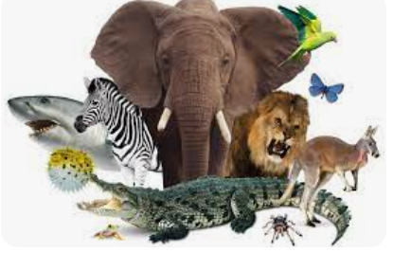  Carnival of the Animals. | Overview:  This expedition is a geography and science focus that links knowledge between the two subjects.  We will be exploring the habitats of the world, thinking about what the climates are like and how animals adapt to survive. We will then compare these world habitats to ones that we find in our country and our locality.  The children will have the opportunity to revisit their knowledge of the continents and oceans of the world to have a better understanding of where in the world these habitats are located.  Our science journey will focus on different types of animals and what they need to survive. We will also learn about how animals obtain food. | 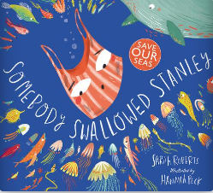  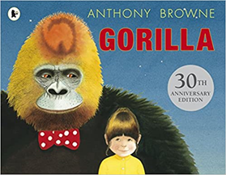  Supporting Texts:  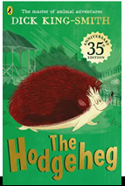  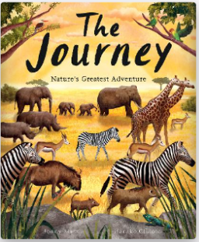  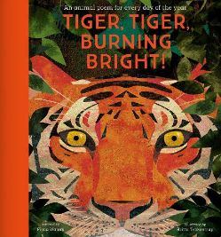  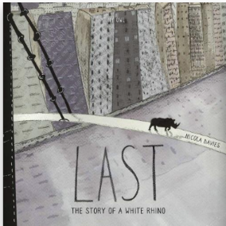  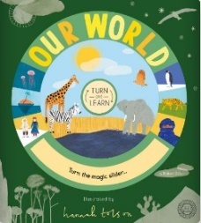  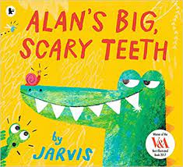  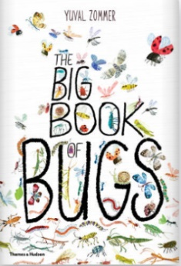  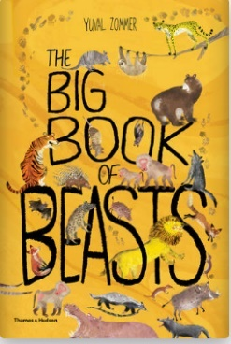  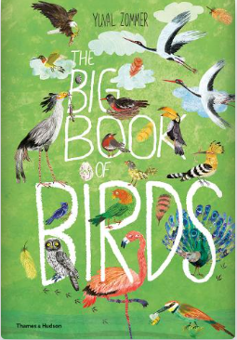  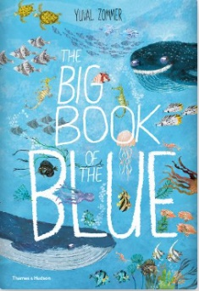  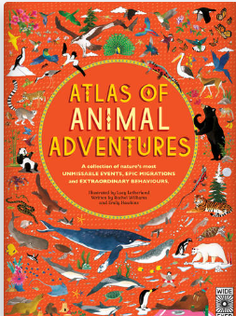  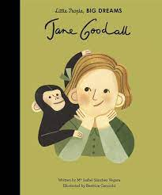  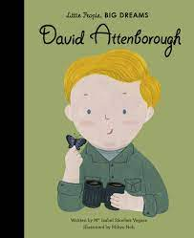  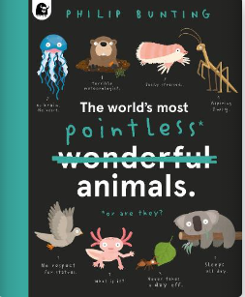
Knowledge:
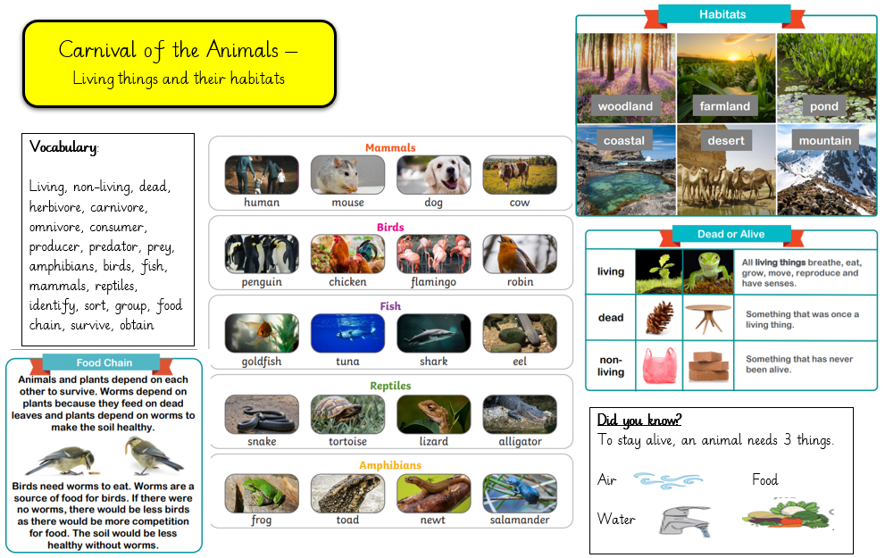
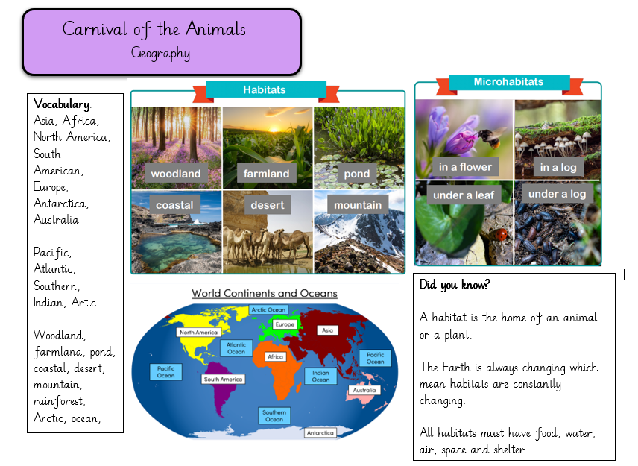

Geography
Our learning focus will be about
Vocabulary:
Asia, Africa, North America, South American, Europe, Antarctica, Australia

Pacific, Atlantic, Southern, Indian, Artic

Woodland, farmland, pond, coastal, desert, mountain, rainforest, Arctic, ocean, habitat, environment, endangered, climate, adapt, globe, atlas, map.

Key Questions:
Week 1: Revisit – What are the 7 continents of the world? What are the 5 oceans of the world?
Week 2: What is the rainforest like? What problems is it facing?
Week 3: What is life like in the ocean?
Week 4: What are the Arctic and Antarctic habitats like?
Week 5: What are the habitats of the UK and our local area?
Week 6: How are environments changing? How does this affect habitats?

Science:
Our learning for this half term will focus on
Vocabulary:

Living, non-living, dead, herbivore, carnivore, omnivore, consumer, producer, predator, prey, amphibians, birds, fish, mammals, reptiles, identify, sort, group, food chain, survive, obtain

Key Questions:
Week 1: What is the difference between things that are living, dead, and things which have never been alive?
Week 2: What are the different types of animals?
Week 3: What are the basic needs of survival for animals? What does carnivore, herbivore and omnivore mean?
Week 4: What do animals eat to survive in their habitats?
Week 5: What are food chains? How do animals obtain food?
Week 6: Who is Jane Goodall? Who is David Attenborough? What have they done for animals?
Art/ DT:
Mask Making
We will be taking inspiration from around the world to see the styles of animal masks different countries have made. We will learn how to create different animal patterns and textures. We will learn how to evaluate, design and mask our own animal masks.
RE:
“Who is Jewish and how do they live?”

