Topic:  Healthy and Happy | Overview:  During this expedition, children will learn about what it means to be healthy and happy. We will begin our journey on learning the different parts of the body before thinking about how we can keep healthy through exercise and eating a well-balanced diet.  The children will reflect on what makes them happy and have time to think about how our local area plays an important role in our lives to promote being healthy and happy. This learning will link to previous learning about our local area.  Finally, the children will be researching different foods and thinking about what makes them healthy before making their own healthy foods. | 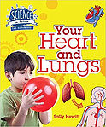  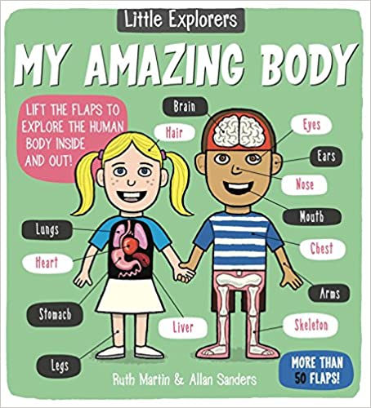  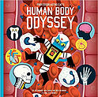  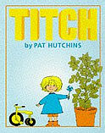  Supporting Texts:  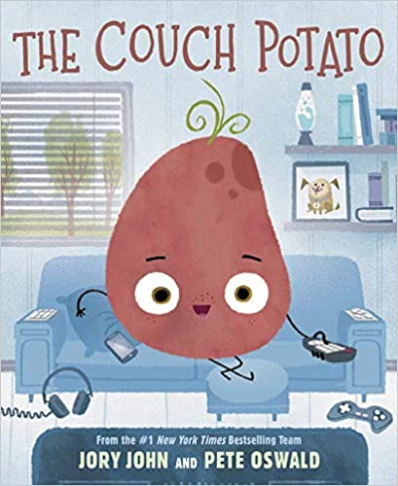  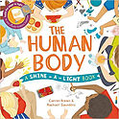  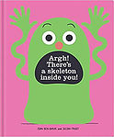  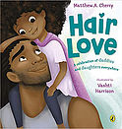  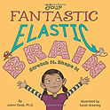  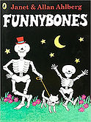  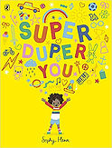  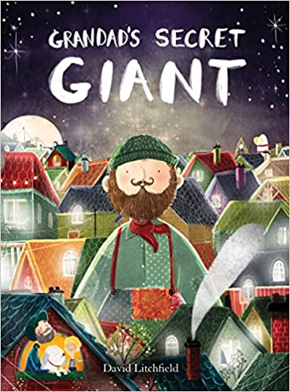  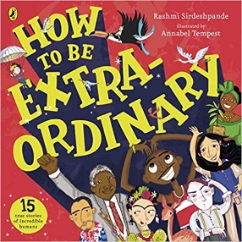
Knowledge:
Science:
Animals Including Humans
Vocabulary:
Omnivore, carnivore, herbivore, diet, senses, sight, hearing, touch, taste, smell, exercise, germs, hygiene, nutrition, air, water, food, healthy, heart rate, pulse.

Key Questions:
Week 1: What are the parts of the human body? What do these parts do?
Week 2: What are our senses? How do we use them?
Week 3: What do animals, including humans need in order to survive?
Week 4: Why is exercise important? How does this help us to be healthy and happy?
Week 5: What is healthy living? How can we live a healthy life? Why is healthy living important?
Week 6: How do animal diets vary? What types of foods do humans need to be healthy?

Geography/ History:

Key Questions:
Week 1: What places make you happy?
Week 2: Why do different places affect our happiness? What makes us lucky to live in Cornwall?
Week 3: Can you plan a walk in the local area?
Week 4: How does going for a walk make you feel? What senses do we use when walking? What happens to our heart rate when walking?
Week 5: How has the pandemic affected our mental health?
Week 6: What other ways can we keep our minds happy and healthy?

Art/ DT:

We will be:
- Looking at existing food packaging and the artistic techniques that are used to attract people.
- Designing and making our own ideas for packaging for a healthy snack bar.
- Researching healthy foods. What is in them? What makes them healthy?
- Making a healthy snack bar based on our research and knowledge of healthy eating.
RE:

‘Who is Jewish and how do they live?’

