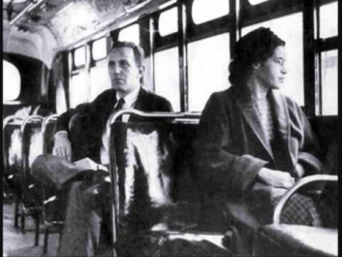
Looking After My Mind, Body and Soul - History

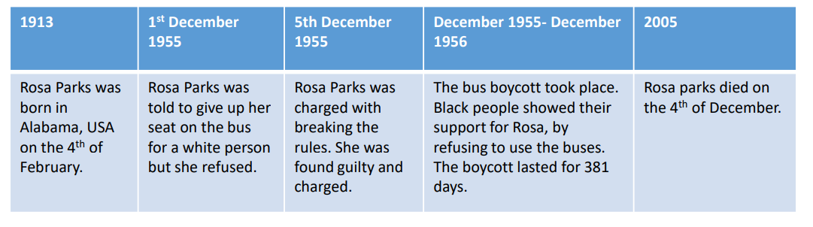
Key Vocabulary
African-America
activist
racism
seat
refuse
equality
segregation
civil rights
bus
prejudice
discrimination
suffragette
protest
women’s rights
King George V
horse
cause
prison
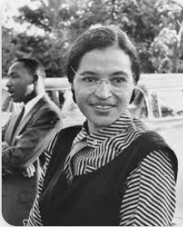

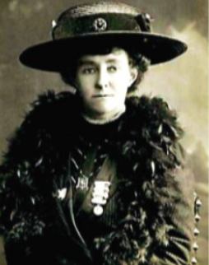
• A women’s equal rights activist who quit her job as a teacher to join the Women’s Social and Political Union.
• The WSAPU was founded by Emmeline Pankhurst.
• Arrested and sentenced in 1909 to a month’s hard labour for public demonstrations
• Attempted to starve herself in protest
• On 4th June 1913, she ran out in front of the King’s horse at Epsom Derby and died of her injuries.
Emily Davison
Rosa Parks

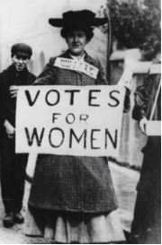
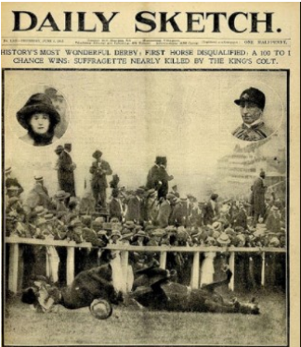

Looking After My Mind, Body and Soul - Senses

