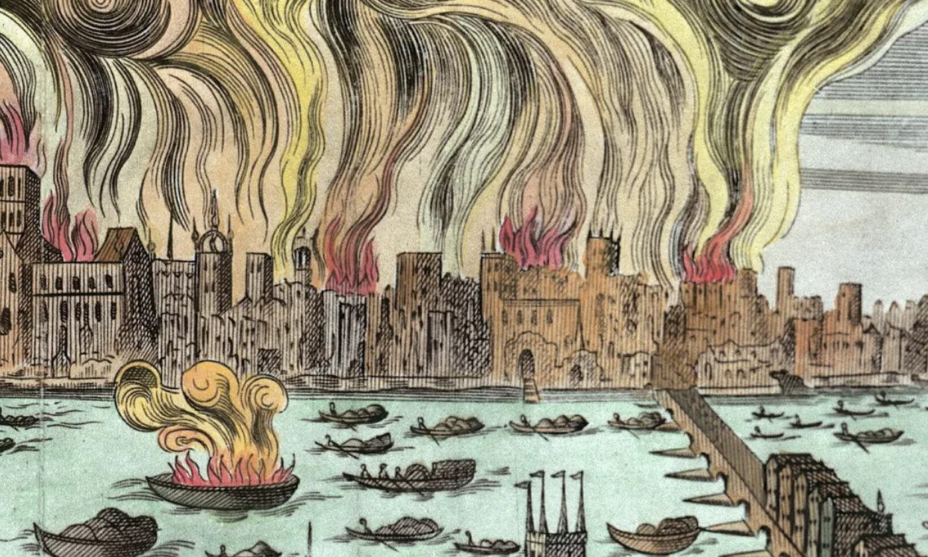
The Great Fire of London
Term 5 Cycle C
Science Plants
Week 1: How do seeds germinate and what happens?
Week 2: What happens when bulbs sprout?
Week 3: What do plants need to thrive and be healthy?
Week 4: What can happen if plants don’t get the things they need?
Week 5: What do I notice about plants around the school?
How are they healthy or unhealthy?

History
Key questions-
Week 1: What was London like in 1666?
Week 2: When was The Great Fire of London and how did it start?
Week 3: Why did the fire spread so quickly and how long did it burn for?
Week 4: Who was Samuel Pepys and why was he important?
Week 5: How did London change after the Great Fire?

Art
Exploring the World through Monoprint
Artists: Xgaoc’o X’are

English
Focus texts
A setting description of Pudding Lane

Grammar
Question marks (Y1 writing and punctuating, Y2 statement, question and command)
Capital letters (Y1)
Expanded noun phrases ( Year 2- determiner, adjective and noun. Year 1- adjectives)
Possessive apostrophes (Y2)
Commas in a list (Y2)

P.E.- Complete P.E.
Tuesday and Thursday
Year 1- Games for Understanding and Reserve
Year 2 – Dodging 1 and Games for Understanding
PSHE
Online friends.
Computing
Internet safety

Maths
Year 1
Mastering number
- Composition
- Comparison
White Rose Maths
Mass and Volume
Multiplication and Division
Fractions
Year 2
White Rose Maths
Fractions
Time
R.E.
Belonging to a faith community

