Expedition:  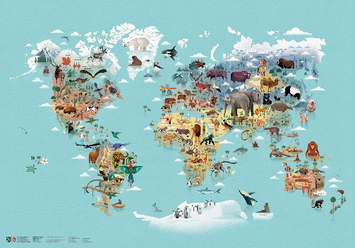  From the tiny ant to the elephant. | Overview:  This expedition is a scientific and geographical study of animals across the world as well as a local wildlife. The children will learn and classify animals that are mammals, reptiles, bird, fish and amphibians. We will explore their differences in terms of appearance, diet, life cycles and habitats. The children will get a chance to revisit their knowledge of the 7 continents of the world and the 5 oceans. We will use this knowledge to explore climates and think how animals are adapted to their habitats. | 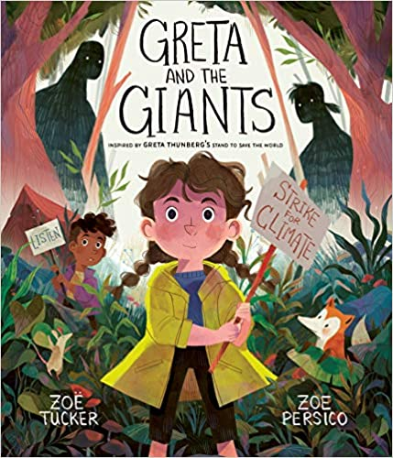  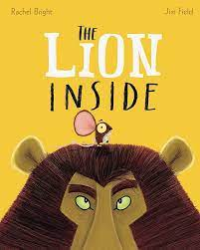  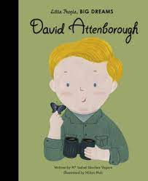  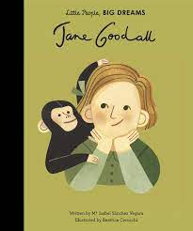  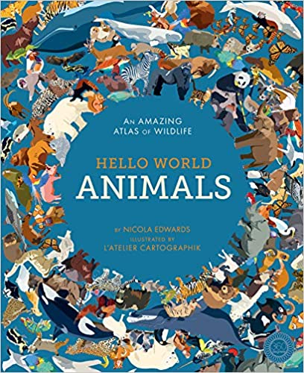  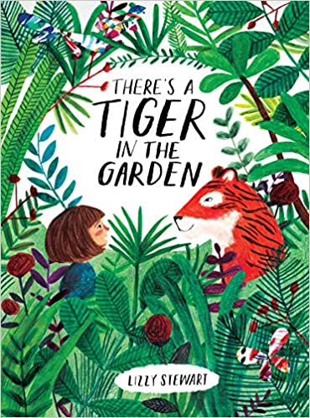  Supporting Texts:  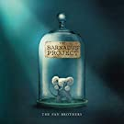  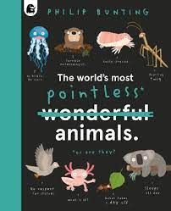  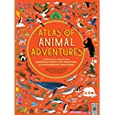  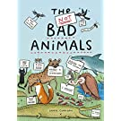  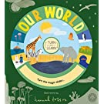  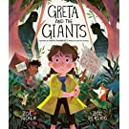  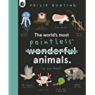  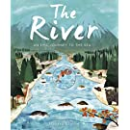  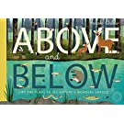  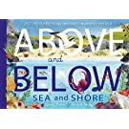  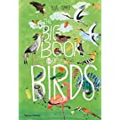  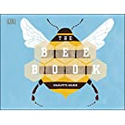  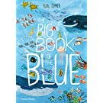  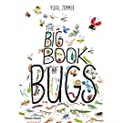  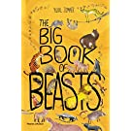
Knowledge:

Science:
Our learning for this half term will focus on all types of animals, what makes them the same and different, what they need to survive and the life cycles of different animals. Science is our main area of learning for this half term.
Vocabulary:
Living, non-living, dead, herbivore, carnivore, omnivore, consumer, producer, predator, prey, amphibians, birds, fish, mammals, reptiles, identify, sort, group, classify.

Key Questions:
Week 1: What is a zoologist? Who are some famous zoologists that we know? What is a mammal, amphibian, reptile, bird and fish?
Week 2: What is the difference between a mammal, amphibian, reptile, bird and fish?
Week 3: What are the differences between things that are living, dead and have never been alive?
Week 4: How do animals obtain food? What do animals need to survive?
Week 5: What offspring is matched to the adult? What is the life cycle of a frog, cow and lizard?

Geography
Vocabulary:
Urban, woodland, pond, coast, habitat, ocean, continent, climate, tropical, desert, globe, atlas, map, Asia, Africa, North America, South America, Antarctica, Europe, Australia, Pacific, Atlantic, Indian, Southern, Arctic.
Our learning will focus on the habitats of different types of animals. We will think about how these animals are suited and adapted to their habitats. As you can see there is not a learning question each week for Geography as the science takes up most of the learning for this term.

Key Questions:
Week 1: What are the 7 continents and 5 oceans called?
Week 2: Where do animals live in our local area? What are their habitats like?
Week 3: What habitats do animals live in around the world? How are habitats suited towards these animals?
Week 4:
Week 5:

Art/ DT:

We will be:
- Researching the work of Peter Cromer.
- We will be recreating a piece of his art work.
- We will be designing and making a piece of art in the style of Peter Cromer.
- We will be using paint and collage techniques.
RE:

‘What does it mean to belong to a faith community?’

