Expedition:  Mawnan and the D-Day Landings.  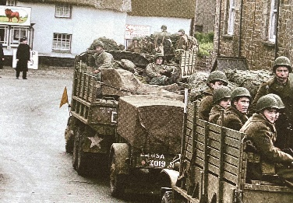 | Overview:  This expedition is a local history study where the children will be learning about Mawnan’s role in the WW2 D-Day landings. We will begin our learning journey by gaining background knowledge as to why WW2 began. We will then learn what D-Day was and the role Mawnan took during this time. | Supporting Texts:  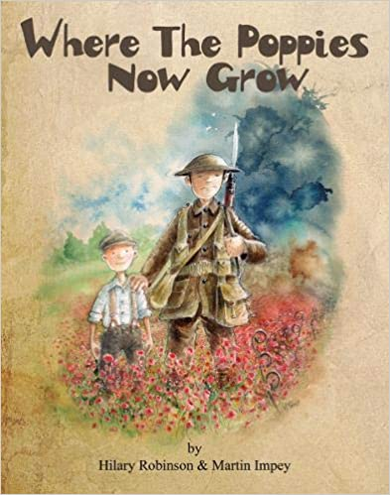  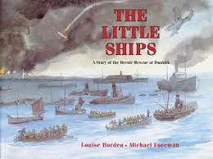  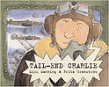
Knowledge:

Science:
Plants
Vocabulary:
Grow, seeds, bulb, roots, stem, leaves, flowers, trunk, tree, garden plant, wild plant, deciduous tree, evergreen tree, dandelion, daisy, rose, pansy, sunflower, maple, oak.

Key Questions:
Week 1: What can we see when we observe the plants around us?
Week 2: How do seeds disperse?
Week 3: What are the parts of a flower?
Week 4: What are the names of some garden and wild plants?
Week 5: What are the different types of trees?
Week 6: What are the similarities and differences of plants?

Geography/ History:
Vocabulary:
D-Day, landings, troops, forces, tank tracks, allies, invasion, army, fortifications, Normandy, remembrance, veterans, Germany, Britain, Canada, France, America, win, defeat, liberate, rationing.

Key Questions:
Week 1: Why did World War Two begin? Which countries took part?
Week 2: What were the D-Day landings?
Week 3: Who came to Mawnan and where did they come from?
Week 4: How did people in Mawnan prepare for the D-Day landings? What was the role of Trebah?
Week 5: What was life like for the Americans who came to Mawnan?
Week 6: What was/ is the lasting impact of the D-Day landings in Mawnan?
English:

We will be learning how to write letters and settings descriptions. The letters will be from the viewpoint of the Americans who came to Mawnan during WW2 and the people who lived in the village at the time. Our narrative descriptions will describe what Mawnan looked like during this period of time.
Art/ DT:

We will be:
- Researching, designing and making WW2 posters.
- Looking at wartime bunting and creating our own.

RE:

Why does Easter matter to Christians?

