Expedition:  Treasures of the Earth  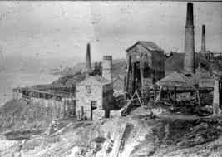 | Overview:  This expedition will allow children to explore and understand the Cornish heritage of mining and what it did for our county. They will learn about the history of what was mined, how it was achieved and the daily lifestyles of miners and their families. Children will explore the geographical locations of the mining areas in Cornwall and the historical changes that have occurred with the landscape, the towns and also with mining in modern times. We will also compare Cornwall’s mines to mines in other locations within the UK and around the world.  In addition, we will delve in to the materials that are below our earth’s surface; we will study them, explore them, compare them and understand how they are used in our everyday lives. This will also allow for opportunities to think about the sustainability of mining these materials and what impact this has upon the future of the Earth. | Class Texts:  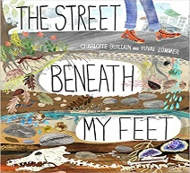  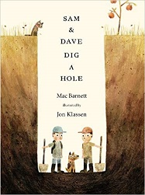  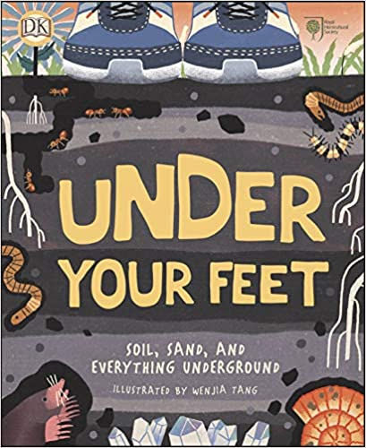  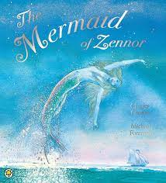  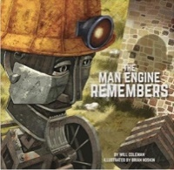  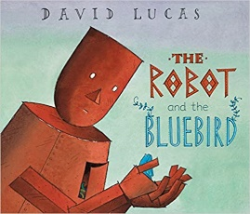
Knowledge:
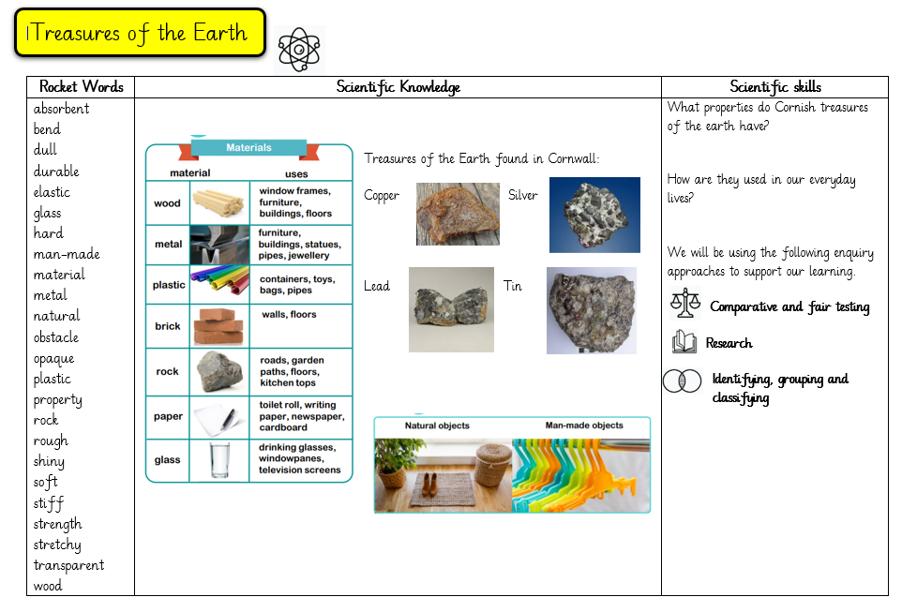
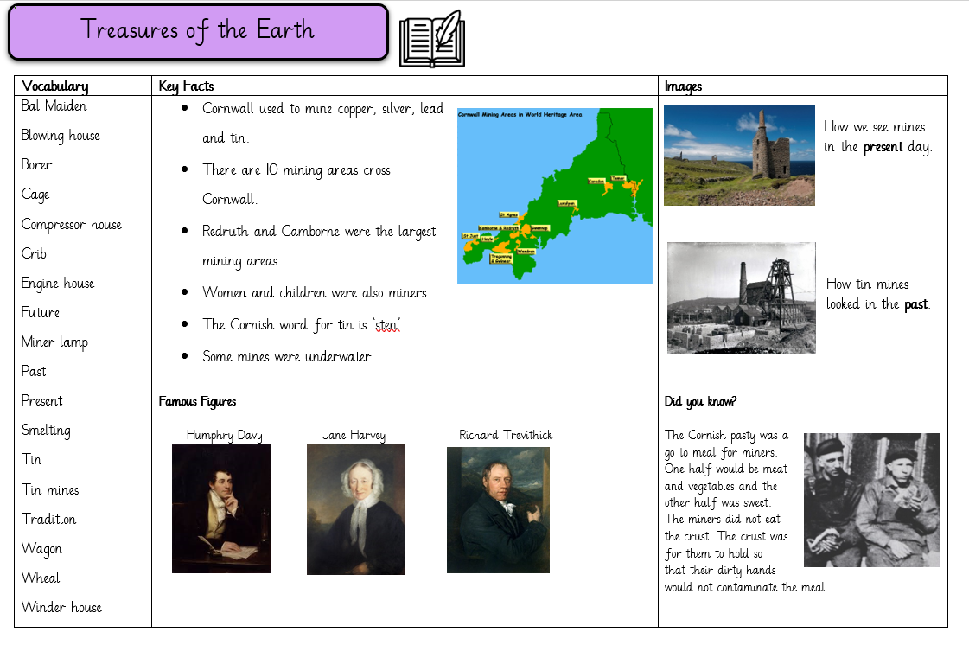
History:

Week 1: What is a mine? Why is mining significant to our county of Cornwall?
Week 2: Where are the mines in Cornwall situated? Why were the mines built there? What did they look like? How do they look today?
Week 3: What was mined in Cornwall and how did people mine?
Vocabulary:
Bal maiden, blowing house, borer, cage, compressor house, crib, engine house, future, miner lamp, past, present, smelting, tin, tin mines, tradition, wagon, wheal, winder house.

Week 4: What was the miner’s safety lamp and who invented it?
Week 5: Who was Richard Trevithick? Why was he important for mining?
Week 6: What were mining towns like in Cornwall? How did they shape the community? How have they changed?
Week 7: When did mining in Cornwall stop? What impact did this have on the county?

Science:
Vocabulary:
absorbent, bend, dull, durable, elastic, glass, hard, man-made, material, metal, natural, opaque, plastic, property, rock, rough, shiny, soft, stiff, strength, stretchy, transparent, wood
Week 1: What are the names of materials? What are they used for?
Week 2: What are the properties of materials?
Week 3: What materials were mined in Cornwall?
Week 4: What are the properties of the materials mined in Cornwall? Why do they need these properties?
Week 5: Where can we identify these mined materials in our local area and everyday lives?

English:

We will begin with revisiting sentence structure, focusing on the place value of grammar. First, children will apply their knowledge by writing labels and captions.Then we will be writing a recount about the day in the life of a miner.

Maths:

Place Value:
Year 1 will be working with numbers up to 20
Year 2 will be working with numbers up to 100.
Art/ DT:

We will be:
- creating tin mines by observing current structures, comparing our own designs to real life mines, thinking how we can make them sturdy and how we can improve our models.
- observing the work of LS Lowry to go on to create our own observational drawings of tin mines and creating a landscape picture.
RE:

‘Who is Muslim and how do they live?’ (part one)

