Expedition:  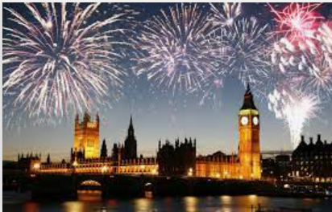  Celebrations | Overview:  This expedition is all about celebrations in our own lives, our communities and countries around the world.  Our learning will start with the history of Guy Fawkes and the significance of bonfire night. We will then learn about the tradition of Christmas and compare Victorian Christmas’s to what we do in our modern lives.  Our geography learning will focus on the four countries of the UK before going on an international journey, across the world to learn where other celebrations take place and learning about Christmas traditions in other countries.  Our learning will also focus on other celebrations during this time of year such as Diwali. | 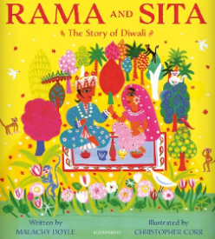  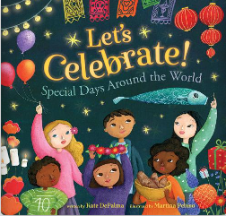  Supporting Texts:  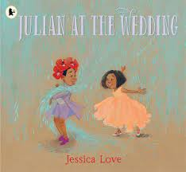  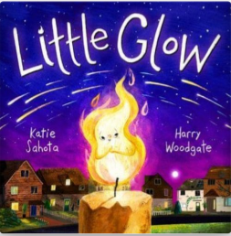  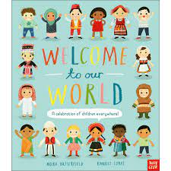  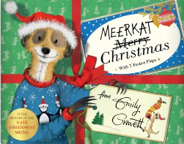  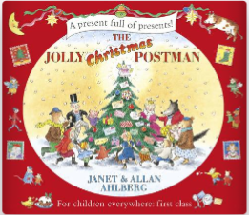  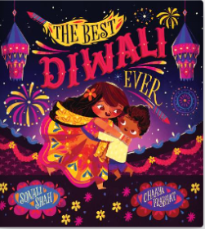
Knowledge:
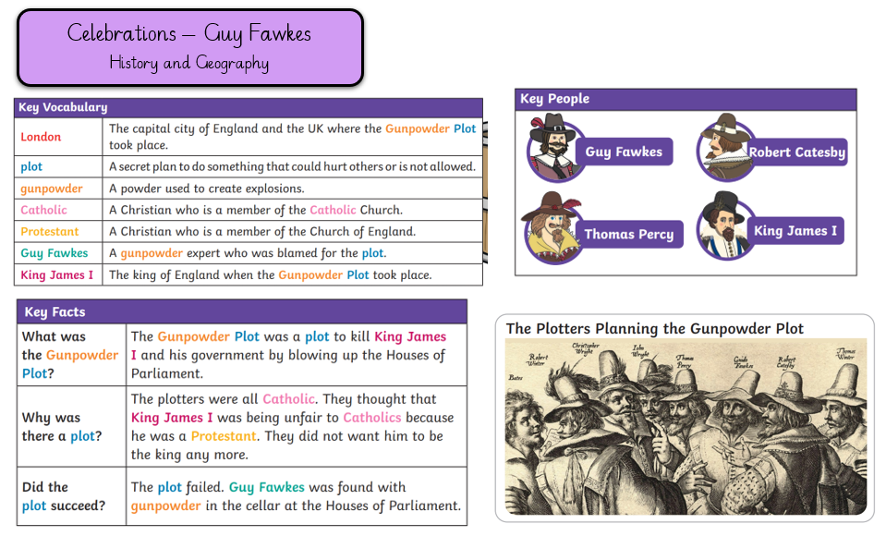
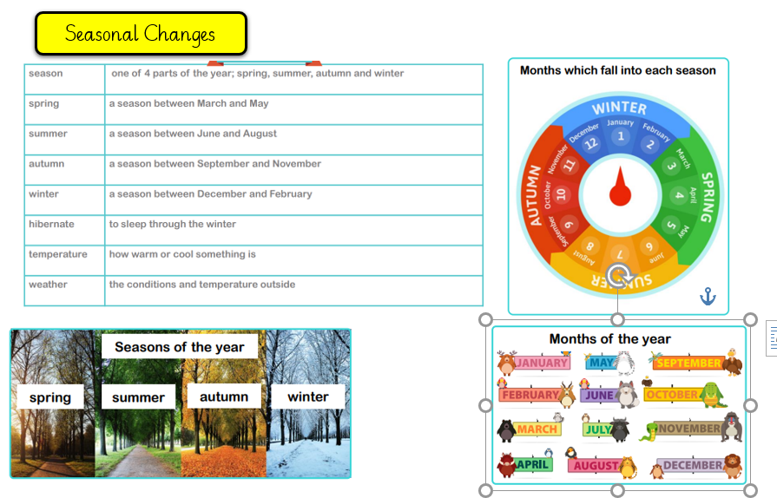

History
Our learning focus will be the history of Guy Fawkes and Christmas Traditions.
Vocabulary:
London, plot, gunpowder, Catholic, Protestant, Guy Fawkes, King James 1.

Victorians, Christmas day, Boxing Day, Queen Victoria, Prince Albert, Christmas tree, celebration, carols, presents, decorations, parlour games

Key Questions:
Week 1: Who was Guy Fawkes?
Week 2: What was the Gunpowder plot? Why did it happen?
Week 3: What is the significance of Bonfire night?
Week 4:
Week 5: How did Victorians celebrate Christmas? What traditions did they bring in?
Week 6: What traditions do we have in our own lives and in our community?
Week 7: How have celebrations changed over time?
Geography:
Our learning focus will be the countries that make up the United Kingdom and continents of the world.
Vocabulary:
Continents:
Asia, Africa, North America, South America, Antarctica, Europe, Australia.

United Kingdom, England, Wales, Scotland, Northern Ireland.

Key Questions:
Week 1: What are the 4 countries that make up the United Kingdom?
Week 2: Where did the Gunpowder plot happen? What significant buildings did it affect?
Week 3: What buildings are used in our local area to hold celebrations?
Week 4: (Revisit) What are the seven continents?
Week 5: How do countries around the world celebrate Christmas? Where are those countries on map? What continent are then on?
Week 6: As last week.
Week 7: Revisit week.

Science:
Our learning for this half term will focus on seasonal changes.
Vocabulary:
Season, spring, summer, autumn, winter, hibernate, temperature, weather, observe

Key Questions:
Week 1: What are the four seasons? (Revisit – How are those four seasons created?)
Week 2: What changes take place in Autumn?
Week 3: What changes take place in Winter?
Week 4 – 7: Weather Observers – can you plan your own enquiry approach to observe the weather?

Art/ DT:

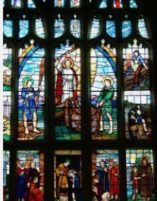
We will be taking inspiration from our local Churches and creating Stained Glass Windows.
As Christmas approaches, we will be making decorations and pop up cards.
RE:
‘What do Christians believe God is like?’

