Expedition:  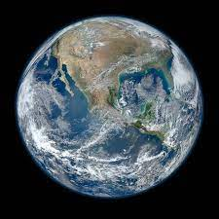  Our Place in Space | Overview:  This expedition focuses on geography, history and science.  The children will be learning about the history of space travel, comparing the explorations of the significant individuals of Neil Armstrong and Tim Peake.  We will be exploring the physical features of the earth, learning how we can identify them from space. We will also use this knowledge to compare the surface of Earth to the surface of the Moon.  Finally, our science learning will focus on how day and night is formed, and learning what gravity is and how that affects the tides. The children will also have the chance to learn why Mae Jemison is a significant individual in the world of space exploration. | Supporting Texts:  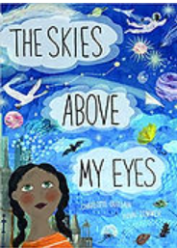  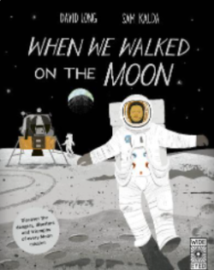  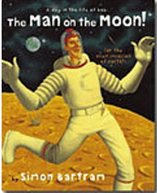  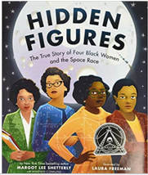  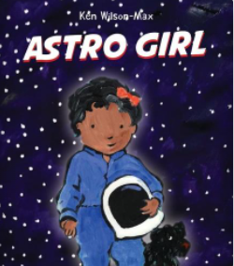  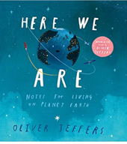  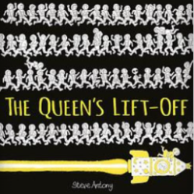  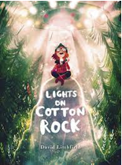  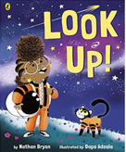  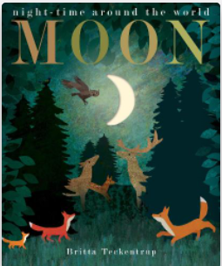  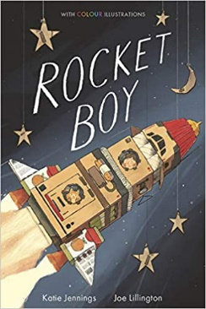
Knowledge:
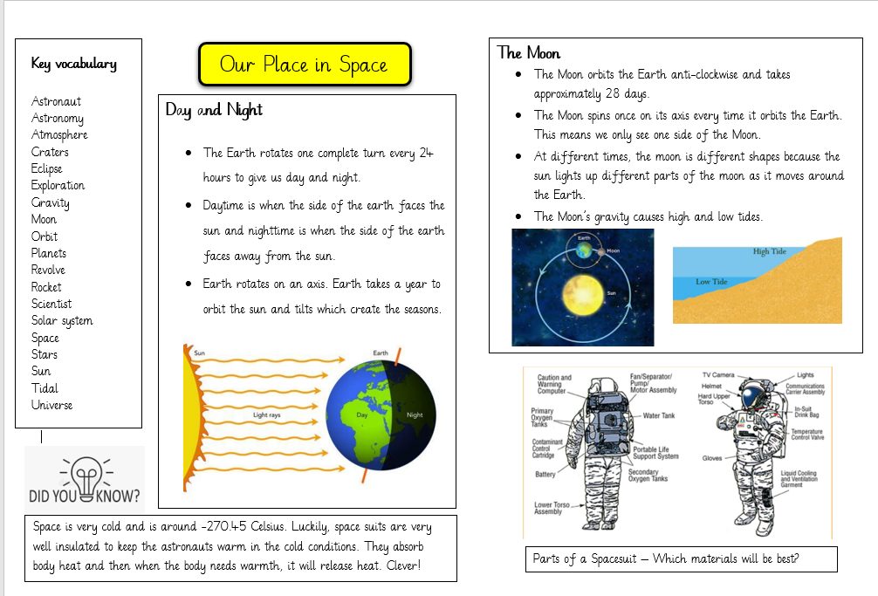
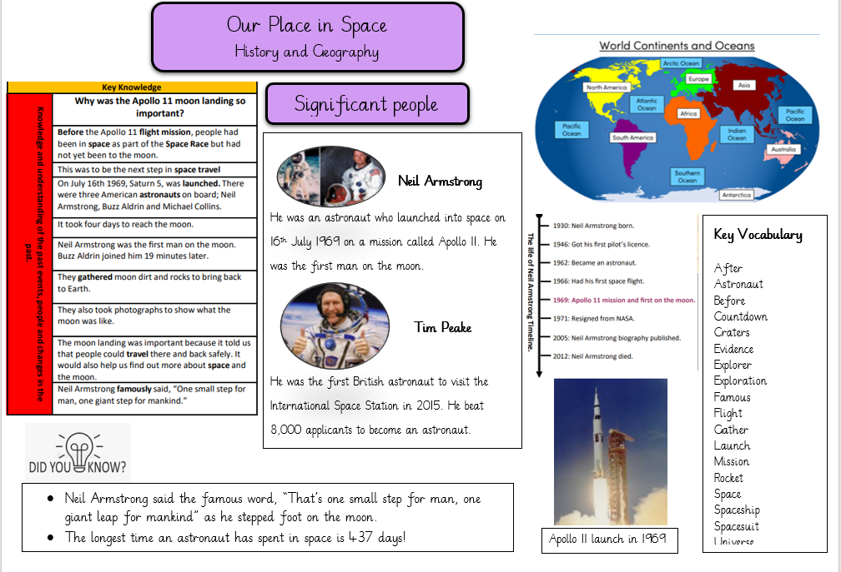

History
Our learning focus will be the history of Space travel and significant people.
Vocabulary:
After, astronaut, before, evidence explorer, exploration, famous, flight, gather, launch rocket, space, universe, countdown, spaceship, spacesuit, mission

Key Questions:
Week 1:
Week 2: How did people travel to space? How do they travel now?
Week 3: What and who is an astronaut? What clothing do they need? How has it changed?
Week 4: Why was the Apollo 11 Moon Landing so important? Who was Neil Armstrong?
Week 5: Who is Tim Peake? How is his exploration different to Neil Armstrong?
Week 6: How and why has space exploration been important? What have we been able to learn? What could it look like in the future?
Week 7: Revisit week.
Geography:
Our learning focus will be physical geography.
Vocabulary:
Continents:
Asia, Africa, North America, South America, Antarctica, Europe, Australia.

Oceans:
Pacific, Atlantic, Southern, India, Arctic

Beach, cliff, coast, forest, hill, mountain, sea, ocean, river, valley.
craters

Key Questions:
Week 1:
Week 2: What are the 7 continents of the world? Can you locate them on a map?
Week 3: What are the 5 oceans of the world? Can you locate them on a map?
Week 4: What physical geographical features can you see from space?
Week 5: How does the surface and features of the moon differ to the world and more specifically, our location?
Week 6:
Week 7:

Science:
Our learning for this half term will focus
Vocabulary:
Orbit, gravity, tidal, astronaut, exploration, rocket, space, stars, planets, universe, astronomy, moon, solar, sun, atmosphere, craters, revolve, solar system, eclipse, scientist

Key Questions:
Week 1:
Week 2: What is space? What do we already know?
Week 3: What materials would a space suit need to be made from?
Week 4: How does the earth orbit the sun? How does day and night work?
Week 5: What is gravity?
Week 6: How do tides work?
Week 7: Who is Mae Jemison and what is she known for?

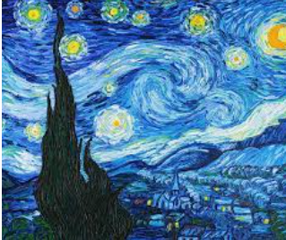
Art/ DT:

We will be taking inspiration from ‘Starry Night’ by Vincent Van Gogh.
The children will be learning how to use line, tone,
RE:
‘Who do Christians say made the world?’

