Expedition:  The Queens  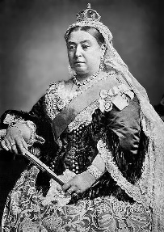  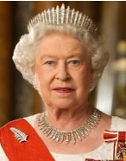  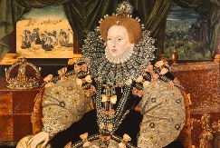 | Overview:  This expedition is a historical journey through time that explores three of the famous Queens of England: Queen Victoria, Queen Elizabeth 1 and Queen Elizabeth 11. We will be exploring how they ruled, the impact they had on the country, what Britain was like during those eras and how their reigns were similar yet also different.  This expedition has a memorable historic event happening in the middle; The Coronation. Therefore, we will spend a week learning about the coronation and the change from Queen to King. | Supporting Texts:  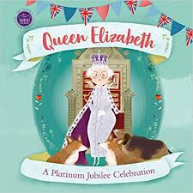  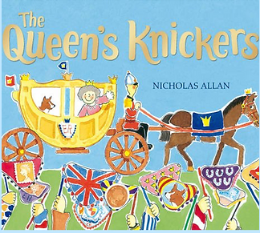  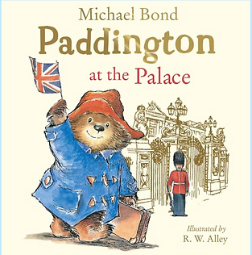  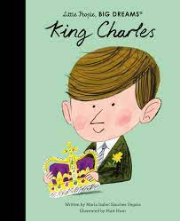  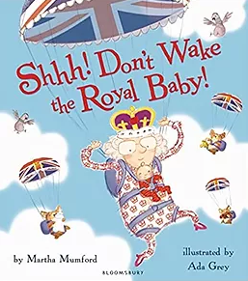  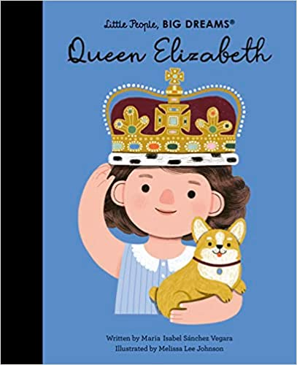  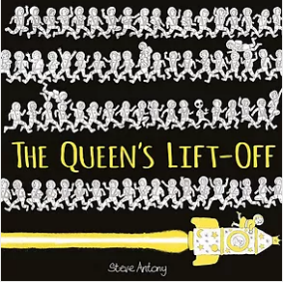  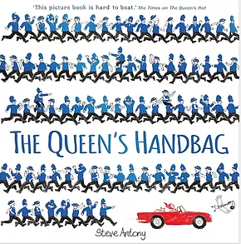  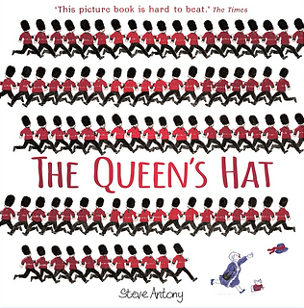
Knowledge:
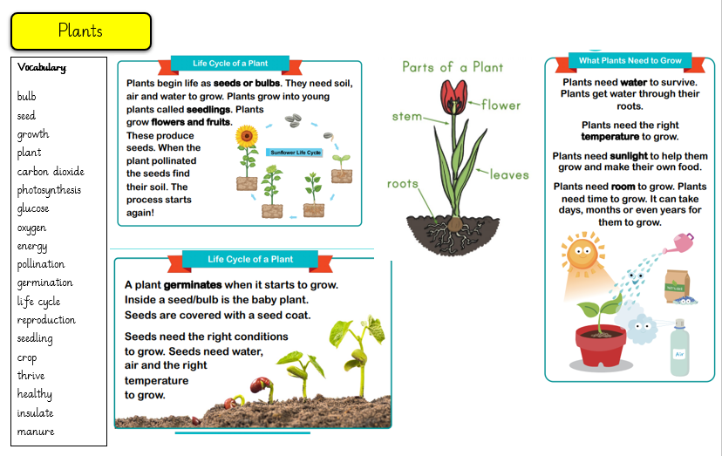
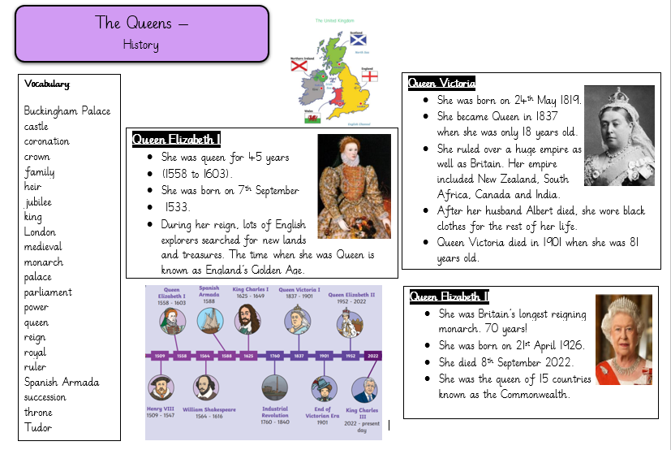

History
Our learning focus is on the historical concepts of hierarchy and power, change and continuity and similarity and difference.
Vocabulary:

Buckingham Palace, castle, coronation, crown, family, heir, jubilee, king, London, medieval, monarch, palace, parliament, power, queen, reign, royal, ruler, Spanish Armada, succession, throne, Tudor

Key Questions:
Week 1: What is a monarch? Who was Queen Elizabeth 1?
Week 2: Who was Queen Elizabeth 11? How was she the same/ different to Queen Elizabeth 1?
Week 3: What is the change from Queen to King? (Coronation Week)
Week 4 - 5: Who was Queen Victoria?
Week 6: How do these periods in time differ? What are the similarities and differences between these monarchs?

Science:
Our learning for this half term will focus on plants
Vocabulary:

bulb, seed, growth, plant, carbon dioxide, photosynthesis, glucose, oxygen, energy, pollination, germination, life cycle, reproduction, seedling, crop, thrive, healthy, insulate, manure

Scientific skills:
Compare, investigate, experiment, method, predict, control

Key Questions:
Week 1: (Revisit – what are the parts of a flowering plant?) What is the difference between seeds and bulbs?
Week 2: How can we design an experiment to explore the needs of plants?
Week 3: What do plants need to grow and stay healthy?
Week 4: What is the life cycle of a plant?
Week 5: What observations and recordings can we make of the growth of plants over time?
Week 6: What is the importance of bees?
Art:
Portraits
We will be using the inspiration of Royal portraits to recreate our own using limited palettes and learning how to use tone.
RE:
‘What does it mean to belong to a faith community?’

