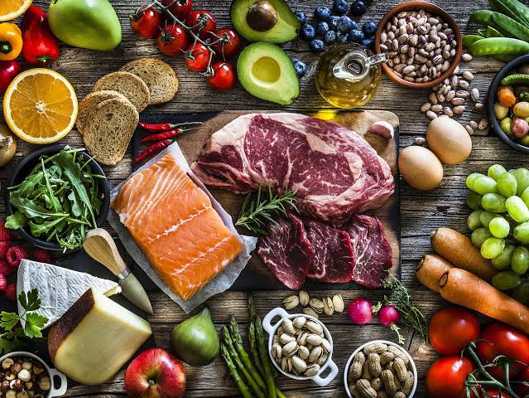
Maths
Year 1
Mastering number
Composition
Comparison
Counting, ordinality and cardinality
White Rose Maths
Place Value within 10
Addition and Subtraction within
Year 2
Mastering number
Composition
Comparison
Counting, ordinality and cardinality
White Rose Maths
Place value within 100
Addition and subtraction

PSHE
-respecting uniqueness
Computing
Coding and Programming
Design and Technology

Joining techniques

Food Glorious Food
Term 1 Cycle A
Science Autumn
Week 1- What is Autumn?
Week 2- Why do trees lose their leaves in Autumn?
Week 3- What is the weather like in Autumn?
Week 4- What does harvest mean?
Week 5- Why do animals hibernate?
Week 6- What happens to the day light hours?

P.E.- Complete P.E.
TUESDAY and THURSDAY
Ball skills (feet)
Orienteering
R.E
Year 1- Who do Christians say made the world? Creation

English
Focus texts
Year 1
Place Value of Grammar and Punctuation
Jack and the Beanstalk
Food from Around the World (Non-chronological Report)

Grammar
Common nouns, proper nouns, verbs, plurals

Year 2 spelling
Vowels and consonants
Compound words

History/Geography
Key questions-
Week 1- Strong Start- maps
Week 2- What is a continent?
Week 3- What is an ocean?
Week 4- What are the four countries and capital cities of the UK?
Week 5- What are the UK’s surrounding seas?
Week 6- Foods from around the world and UK- tasting and learning session

