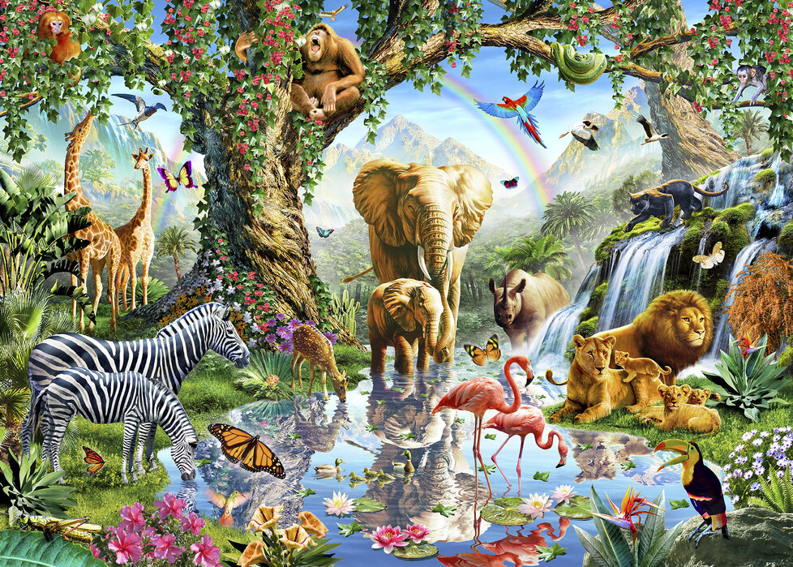
Carnival of the Animals
Term 4 Cycle A
PSHE
Internet safety
P.E.- Complete P.E.
TUESDAY and THURSDAY
Team Building and Dance

Art- Access Art
Flora and Fauna
Mixed Media and collage
R.E
Why does Easter matter to Christians?
Science Humans inc. Animals- Animals
Week 1: What types of animals are there? Birds and Mammals
Week 2: What types of animals are there? Reptiles, amphibians and Fish
Week 3: What is similar and what is different? Year 1 What are their habitats? Year 2: What habitats do animals live in? How do these habitats meet the needs of the animals?
Week 4: What are the basic needs of survival for animals?
Week 5: What does carnivore, herbivore and omnivore mean? (Year 2: How does an animal depend on its habitat for food – food chains) Which animals fall in to those categories?

English
Focus texts
African Animals- A non-chronological report
The Treasures by Clare Bevan

Grammar
Plurals Synonyms
Proper nouns- revisit Verbs
Conjunctions- and, but, so Adjectives

Year 2: Reading comprehension
Computing
Internet safety
Geography
Key questions-

Week 1: Where is the Equator?
Week 2: Where is it hot and where is it cold on Earth?
Week 3: Where are the North and South pole? What are they like?
Week 4: Where are hot countries and what are they like?
Week 5: What do I know about hot and cold places?

Maths
Year 1
Mastering number
-Composition
- Counting, cardinality and ordinality
White Rose Maths
Place Value within 50
Height and Length
Mass and Volume
Year 2
Mastering Number
- Composition
White Rose Maths
Multiplication and division
Length and height
Mass, capacity and temperature

