Expedition:  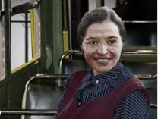  Looking after myself: mind, body and soul.  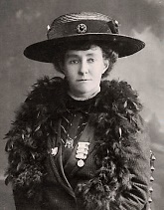 | Overview:  This expedition has a history focus about two significant female individuals; Rosa Parks and Emily Davison. We will explore what they did in their lives that makes them significant. We will also learn about the impact that their actions have on today’s society.  The science focus in this expedition is an exploration of our senses. We will be conducting scientific enquiries to enhance our learning and our understanding of how our senses work. | 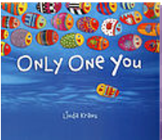  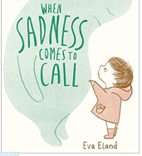  Supporting Texts:  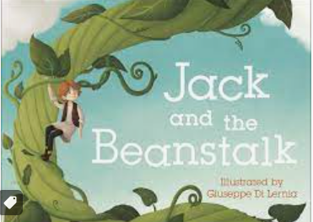  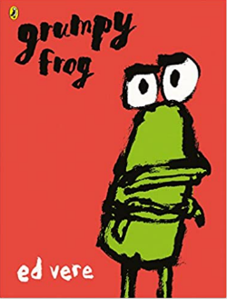  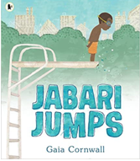  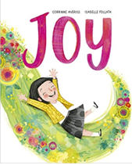  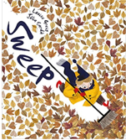  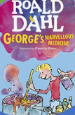  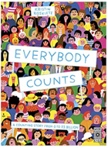  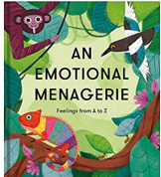  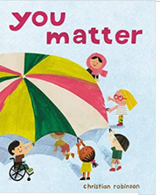  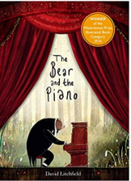  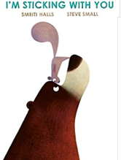  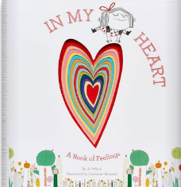
Knowledge:
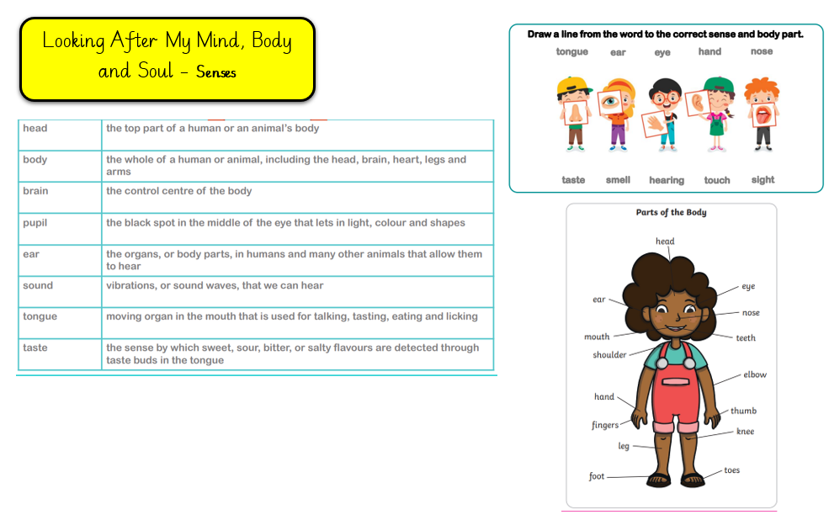
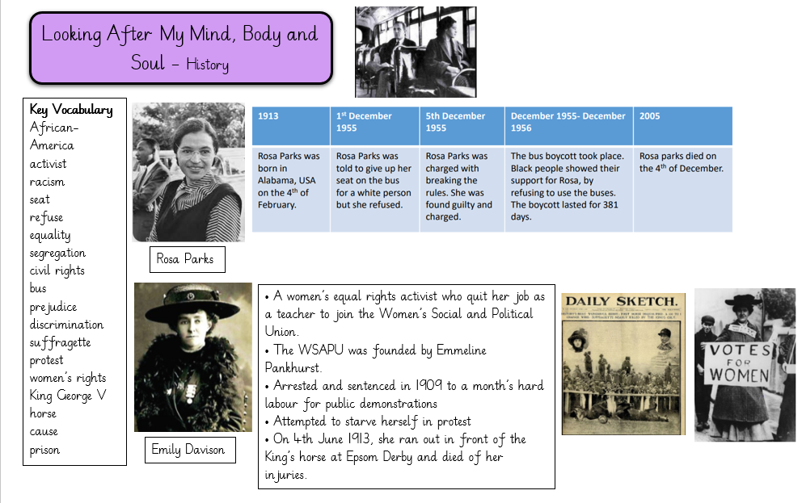

History
Our learning focus will be about the lives of the significant individuals Rosa Parks and Emily Davison.
Vocabulary:

African-American, activist, racism, seat, refuse, equality, segregation, civil rights, bus, prejudice, discrimination.

Activist, suffragette, protest, women’s rights, King George V, horse, cause, prison.

Key Questions:
Week 1: Who were the Suffragettes?
Week 2: Who was Emily Davison? Why was she significant?
Week 3: Who was Rosa Parks? Why was she significant?
Week 4: What similarities and differences are there between Rosa Parks and Emily Davison?
Week 5: Why are Rosa Parks and Emily Davison significant? What impact did these events and people have on life today?
Week 6: How do these women link to other significant individuals that we have already learnt about?

Science:
Our learning for this half term will focus on our senses.
Vocabulary:

Skull, joint, brain, lung, heart, limb, body, skeleton, head, eye, sight, eyelash, pupil, sound, ear, vibration, deafness, sign language, flavor, mouth, taster, tongue, sweet, touch, fingertips, skin, organ, smell, odour, nose, nostril, nose hair.

Key Questions:
Week 1: What are the basic parts of the human body?
Week 2: What are the basic parts of our eyes? How do the parts of the eye function?
Week 3: How do our ears help us hear? What is sound made up of?
Week 4: Why is our sense of taste important?
Week 5: How can we use our sense of touch? What does our skin do?
Week 6: What does our nose allow us to do?
Art/ DT:
Weeks 1 – 3: We will be studying the figure drawing by Alberto Giacometti and will have a go at recreating our own versions. Our learning will focus of the art concepts of line and tone.
Weeks 4 – 6: We will be learning about the ingredients used in flapjacks and will use this knowledge to come up with our own healthy flapjacks which will be make and evaluate.

RE:
“Who is Jewish and how do they live?”

