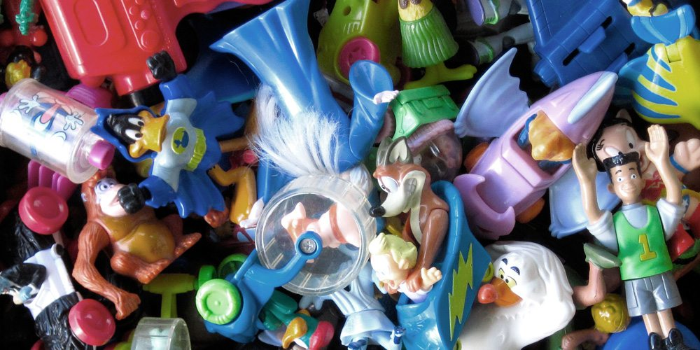
English
Focus texts
Year 1 and 2
Place Value of Punctuation and Grammar- Toy man sentence building
The Adventures of Toy Man (recount)
Toy man (character description)
Grammar
Year 1
Capital letters for proper nouns
Coordinating conjunction ‘and’
Year 2
Expanded noun phrases
Coordinating conjunctions and, but, so
Apostrophes for possession
Suffix -ed

History/Geography
Key questions-
Week 1: What is chronology?
Week 2: What is the oldest toy you have?
Week 3: What toys did your parents and grandparents play with? (visitor)
Week 4: How have toys changed in the last 100 years?
Week 5: Who played with toys in the past?
Week 6: What will toys be like in the future?
Week 7: Bring and Buy sale

PSHE
Dental care
NSPCC – our bodies
PANTS rules
Maths
Year 1
Mastering number
-Composition
- Counting, cardinality and ordinality
White Rose Maths
Height and Length
Mass and Volume
Multiplication and Division
Year 2
Mastering number
-Composition
- Counting, cardinality and ordinality
White Rose Maths
Time
Mass, capacity and temperature
Statistics
Position and direction
P.E.- Complete P.E.
TUESDAY and THURSDAY
Year 1- Tennis and Games for Understanding

Computing
Scratch Junior (coding)
Design and Technology
Joining techniques
Wheels and axel
R.E
What makes some places special to believers? (Thematic)

Science Plants
Week 1: Do wild plants grow in our local area?
Week 2: How can we group plants?
Week 3: Can we eat plants?
Week 4: Which plants can we eat?
Week 5: Are all seeds the same?
Week 6: Where will they grow?
Week 7: How do plants grow and change?

Toys
Term 6 Cycle A

