Fusion Homework Grid – Summer 2
 | Week 1 - W/B – Monday 2nd June | Week 2 - W/B – Monday 9th June | Week 3 - W/B – Monday 16th June | Week 4 - W/B – Monday 23rd June | Week 5 - W/B –  Monday 30th June | Week 6 - W/B –  Monday 7th July
 | DUE: Monday 9th June | DUE: Monday 16th June | DUE: Monday 23rd June | DUE: Monday 30th June | DUE: Monday 7th July | DUE: Monday 14 th July
English  Writing task inspired by the image (20 mins a week) | Natural Disaster  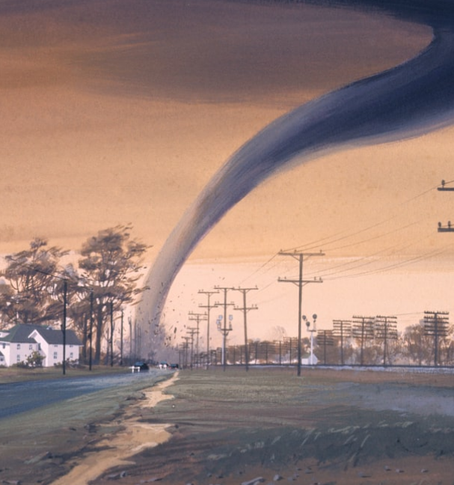 | The Voyage   | View from the moon   | XC3   | The road ahead   | Unexpected guest  
Times Tables  5 minutes a day | Times Table Rockstars Online three times a week  Times Table Rockstars Sheet twice a week | Times Table Rockstars Online three times a week  Times Table Rockstars Sheet twice a week | Times Table Rockstars Online three times a week  Times Table Rockstars Sheet twice a week | Times Table Rockstars Online three times a week  Times Table Rockstars Sheet twice a week | Times Table Rockstars Online three times a week  Times Table Rockstars Sheet twice a week | Times Table Rockstars Online three times a week  Times Table Rockstars Sheet twice a week
Spellings  Spellings will be tested every Friday. | Challenge words:  achieve  apparent  bargain  bruise  community  mischievous  muscle  necessary  vehicle  system | Words with hyphens  co-author  co-operate co-ordinate  co-own  re-educate, re-energise  re-enter  re-evaluate  re-examine  re-explain | NO SPELLINGS DUE TO CAMP  OPTIONAL WRITING TASK FOR YEAR 5’S  YEAR 4’S PLEASE COMPLETE POBBLE WRITE AND TIMES TABLES | Challenge words:  afterwards  amateur  ancient  changeable  deceive  doubt  knight  referring  sincere  immediate | Revision words:  accompany  achieve  advice  affect  aisle  bought  cereal  definitely  guessed  though | Revision words:  conscious  constant  controversy  comfortably  earlier  elegance  fictitious  frequent  manageable understandable
English task - Your child needs to complete the English task each week and should take around 20 minutes. These writing tasks are inspired by an image and they can write freely in any genre they choose, for example: a diary entry, a story, a newspaper report, setting description, instructions, poetry or non-chronological report.
Times Tables - Your child needs to complete the Times Table Rockstars (TTRS) sheets twice a week and play on TTRS online three times a week (5 minutes).
Spellings - Your child needs to practise their spellings every day by using the Look, Say, Cover, Write & Check spellings grids.
Reading - Your child needs to read every day and record this in their reading diary. Signed reading diaries and books need to be brought into school every day.
All homework tasks should be completed in the Home Learning books and will be collected and checked every Monday. If you have any questions or worries, please don’t hesitate to get in touch. Thank you for all your support, Mrs Luscombe and Mrs Davies.

