Expedition:  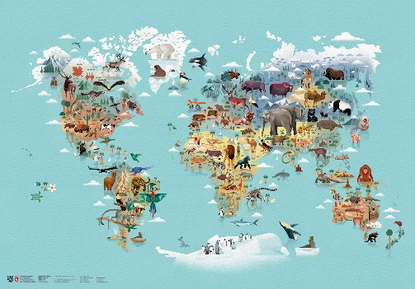  From the tiny ant to the elephant. | Overview:  This expedition is a scientific and geographical study of animals across the world as well as a local wildlife. The children will learn and classify animals that are mammals, reptiles, bird, fish and amphibians. We will explore their differences in terms of appearance, diet, life cycles and habitats. The children will get a chance to revisit their knowledge of the 7 continents of the world and the 5 oceans. We will use this knowledge to explore climates and the animals that live there. | 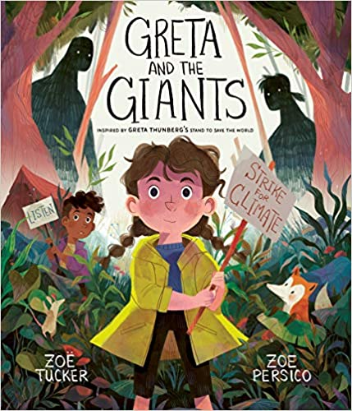  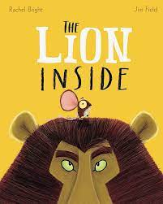  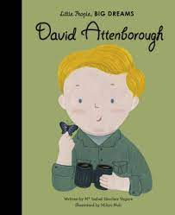  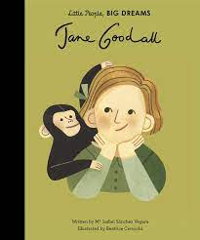  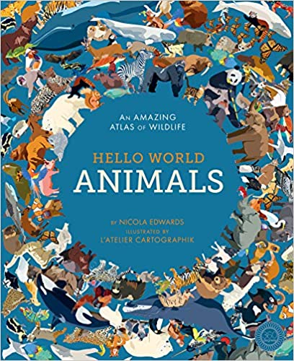  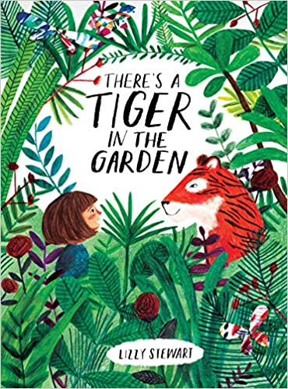  Supporting Texts:  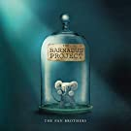  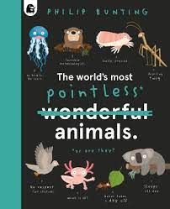  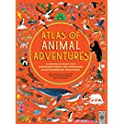  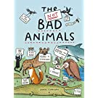  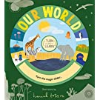  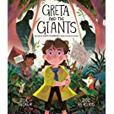  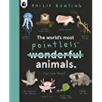  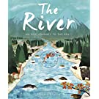  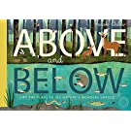  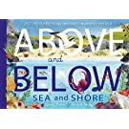  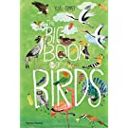  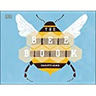  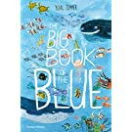  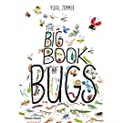  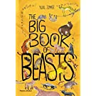
Science:
Key Questions:
Vocabulary:
Living, non-living, dead, herbivore, carnivore, omnivore, consumer, producer, predator, prey, amphibians, birds, fish, mammals, reptiles, identify, sort, group, classify.
Week 1: What and who is a zoologist? What are some examples of different animal families?
Week 2: What is the difference between mammals and birds?
Week 3: What is the difference between amphibians, reptiles and fish?
Week 4: What are the types of food living things eat?
Week 5: What is the difference between wild animals and pets?
Week 6: What are characteristics of animals?

Geography
Vocabulary:
Urban, woodland, pond, coast, habitat, ocean, continent, climate, tropical, desert, globe, atlas, map, climate, equator, hemisphere Asia, Africa, North America, South America, Antarctica, Europe, Australia, Pacific, Atlantic, Indian, Southern, Arctic.

Key Questions:
Week 1: What are the 7 continents and 5 oceans called?
Week 2: What are the 4 countries of the United Kingdom and their capital cities?
Week 3: What is the climate of Europe, the UK and Cornwall?
Week 4: What climates are there in the Northern Hemisphere?
Week 5: What climates are there in the Southern Hemisphere?

Art/ DT:

We will be:
- Researching the work of Peter Cromer.
- We will be recreating a piece of his art work.
- We will be designing and making a piece of art in the style of Peter Cromer.
- We will be using collage techniques.
RE: Gospel

‘What is the good new Jesus brings?’

