Topic:  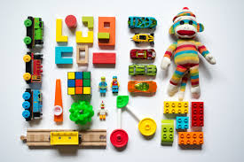  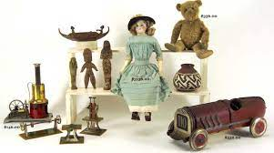  Toys | Overview:  Our topic of toys will give the children a breadth of knowledge about toys past and present. We will take on an historical approach by learning about toys from decades gone by as well as learning about toys during the Victorians which we will then compare to our own toys in modern day. The children will learn about how toys have developed over time and make links to the introduction of technology and its advances over the years. The children will also investigate what materials toys are made from and form their ideas through observation and investigations as to what the best material for toys are. In addition, we will also be learning about significant toys from around the world and making comparisons to what we have in this country. | 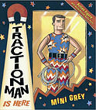  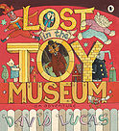  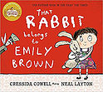  Books:  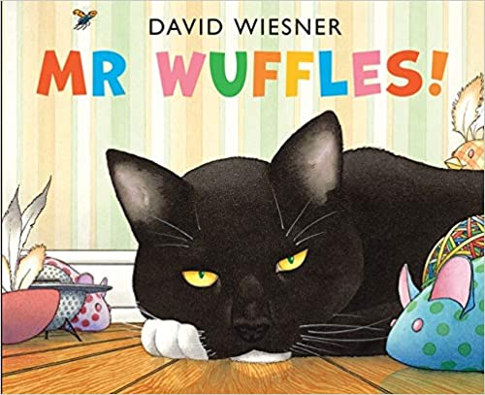  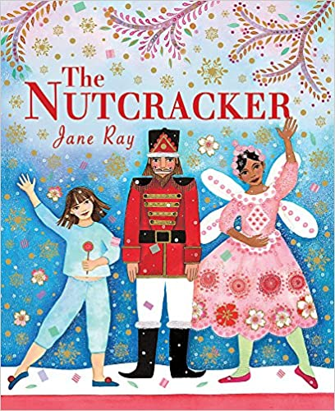  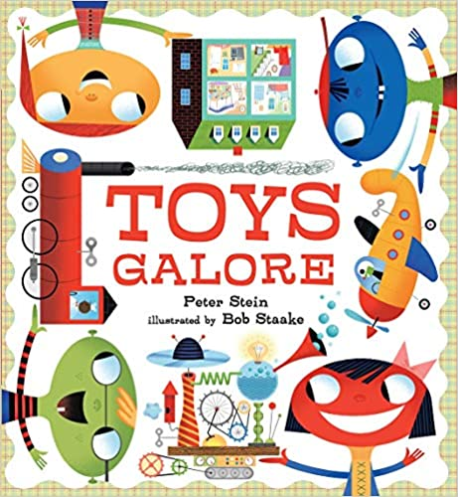  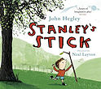  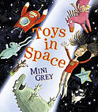  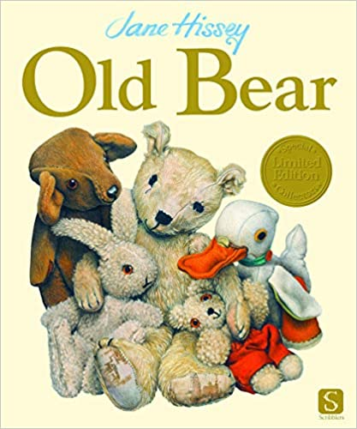  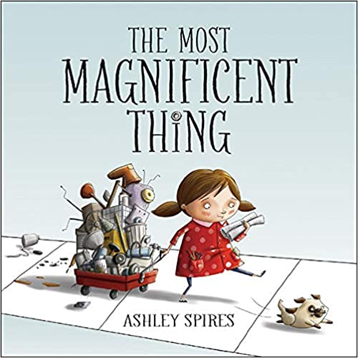  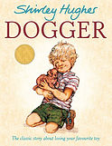  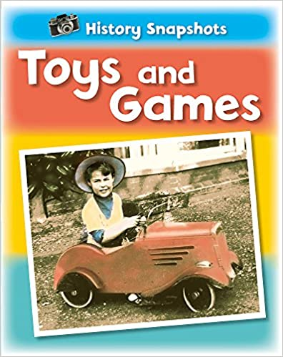  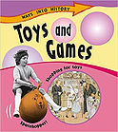  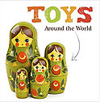  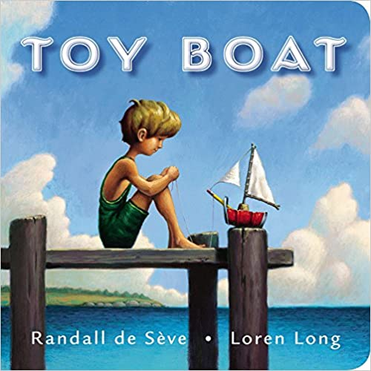
Knowledge:
Science:

Year 1: Everyday Materials
Vocabulary:
Wood, rock, metal, glass, plastic, cardboard, brick, paper, transparent, opaque, materials, stiff, soft, shiny, rough, bendy, stretchy, absorbent, water, smooth, waterproof, dull, hard.
Year 2: Use of Everyday Materials

We will be learning about different materials and each of their properties. We will also be investigating which material is most suitable for specific toys and why.

Key Questions:
What are the main materials used for toys?
What are the properties of each material?
Which is the best material for toys? Why?
How have materials for toys changed over the years?
Why is it important to recycle materials?
What items can be recycled?
How can we recycle materials for new toys?

Geography:
Vocabulary:
Map, atlas, country, continent, hemisphere, global

We will be thinking about and exploring different toys from around the globe.

Key Questions:
Where do toys come from?
What are the traditional toys for different countries?
How are their toys different to ours?

History:
Vocabulary:
Toys, favourite, today, Victorian, then, now, before, after, evidence, sources, past, present, old, older, oldest, question, new, newer, newest, compare, century
We will learn about how toys have changed in the past by comparing toys from the Victorian era, right through to changes in the children’s lives. We will also learn about significant inventors of toys, the history of the teddy bear and reflecting on what our favourite toys are.

Key Questions:
How have toys changed in my lifetime?
What toys did my parents play with?
What toys did my grandparents play with?
How have toys changed over time?
What did Victorian children play with? How are their toys different to mine?
Who was Richard Steiff?
Who was Ole Kirk Christiansen?
Who was Ruth Handler?
Art/ DT:

We will be:
- Making observational drawings of teddy bears using the text, ‘Old Bear’ by Jane Hissey for inspiration.
- Making sock puppets.
- Thinking how toys work by looking at pulleys and levers.
RE:

‘What do Christians believe God is like?’
Our RE learning will explore the stories of ‘The Lost Son’ and the story of Jonah. We will explore the themes of forgiveness, prayer and why Christians sing hymns. The children will also revisit the Christmas story as we approach the festive season.

