Topic:  Treasures of the Earth  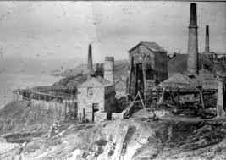 | Overview:  This topic will allow children to explore and understand the Cornish heritage of mining and what it did for our county. They will learn about the history of what was mined, how it was achieved and the daily lifestyles of miners and their families. Children will explore the geographical locations of the mining areas in Cornwall and the historical changes that have occurred not only with the landscape, but also with mining in modern times. We will also compare Cornwall’s mines to mines in other locations within the UK and around the world.  In addition, we will delve in the materials that are below our earth’s surface; we will study them, explore them, compare them and understand how they are used. This will also allow for opportunities to think about the sustainability of mining these materials and what impact this has upon the future of the Earth. | Books:  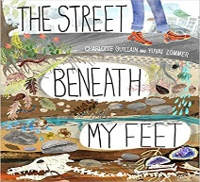  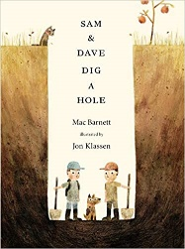  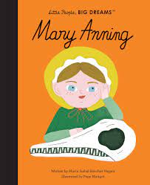  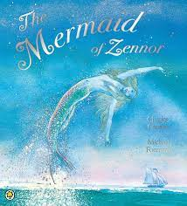  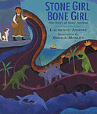  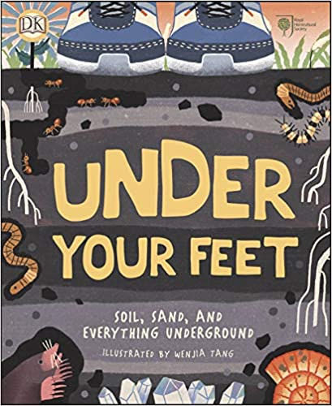  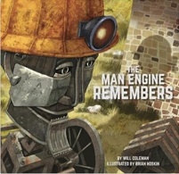  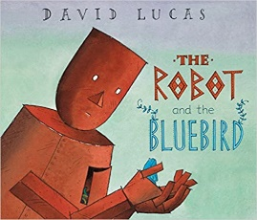
Knowledge:
Science:

Year 1: Everyday Materials
Year 2: Use of Everyday Materials
Vocabulary:
Glass, metal, rock, plastic, wood, transparent, waterproof, opaque, materials, stiff, soft, shiny, rough, bendy, stretchy, absorbent, water, smooth, dull, hard, durable, natural, man-made, granite, igneous, magma, metamorphic, quartz, sedimentary, serpentine, tin
We will be exploring a range of different materials before explicitly looking at materials such as
rocks, crystals and other mined materials.

Key Questions:
Can you identify and name these materials?
What are the uses of these materials?
What are their properties?
How can we group these materials?
How are these materials used?
Where can we see these materials in our local area?
How do crystals form?
How is what we mine, changed to fit its purpose?
What is a fossil?
Geography:

We will be focusing on the mining landscape of Cornwall by comparing the coastal and town locations.
Vocabulary:
Beach, cliff, coast, hill, sea, city, town, village, harbor, location, situated, plot, climate, compare, contrast
We will also compare and describe mines in other parts of the country and around the world.
In addition, we will also look at the sustainability of mining and the impact it has on climate change.

Key Questions:
Where are mines situated in Cornwall?
Can you describe the surrounding areas?
Can you use a map to find and locate the mines and villages/ towns of Cornwall?
Why were mines in these areas?
How are Cornwall’s mining locations different nowadays to the past?

History:
Vocabulary:
Mining, tin mines, tradition, past, present, future, tin, copper, lithium, battery lamp, blowing house, borer, cage, compressor house, crib, engine house, wagon, wheal, winder house.
We will learn about the history of mining in Cornwall and the changes it has faced.

Key Questions:
What changes were made to mining in Cornwall?
How are Cornwall’s mining locations different nowadays to the past?
What were the mining traditions?
How is mining different from past to present?

Art/ DT:

We will be:
- Creating tin mines by observing current structures, comparing our own designs to real life mines, thinking how we can make them sturdy and how we can improve our models.
- Making Cornish Pasties.
- Observing the work of LS Lowry to go on to create our own observational drawings of tin mines and creating a landscape picture.
RE:

‘Who do Christians say made the world?’
Here we will be exploring the creation story and thinking about how people can show respect for the world around them.

