OTHER COUNTRIES  TOPIC: Natural Disasters  TERM: Spring 1  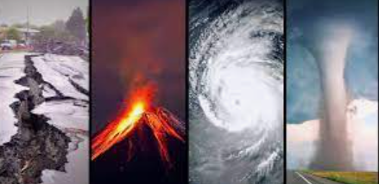 | 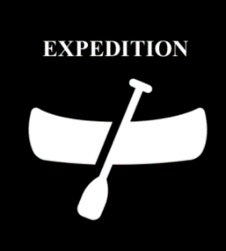  Expedition Overview:  This term, the expedition will have a big geography focus where the children will learn about various natural disasters and will focus particularly on volcanoes, earthquakes and tsunamis. They will learn about the features of volcanoes and their formation as well as the features and key aspects of earthquakes. The children understand what an emergency is as well as why and how people around the world prepare for emergencies. |  | Books:  Orphans of the Tide by Struan Murray  (Main whole class text, 1 copy each)  Natural Disasters DIY Survival Manual (Main whole class text, 1 copy each)  Escape from Pompeii by Christina Balit  Flood by Alvaro F. Villa  Street Beneath my Feet by Charlotte Guillain
Key concepts:  boundaries (continents, localities, nations) cartography (atlases, directions, distance, Equator, latitude, longitude, maps, scale, symbols) change (adaptation, sustainability) climate (climate change, climate zones, pollution, weather) interdependence (economy, trade) movement (migration, navigation, transport) physical geography (biomes, bodies of water, tectonics, topography) resources (energy, food supply, infrastructure) settlements (population, rural areas, urban areas) |  | Research, Describe, Observe  Recognise (Name, Identify, Locate)  Measure-Record-Present  Understand (Explain, Interpret, Compare and Contrast)  Conclude (Analyse, Opinion)  Make Judgements (Debate, Evaluate, Predict)  Key skills:

Knowledge:  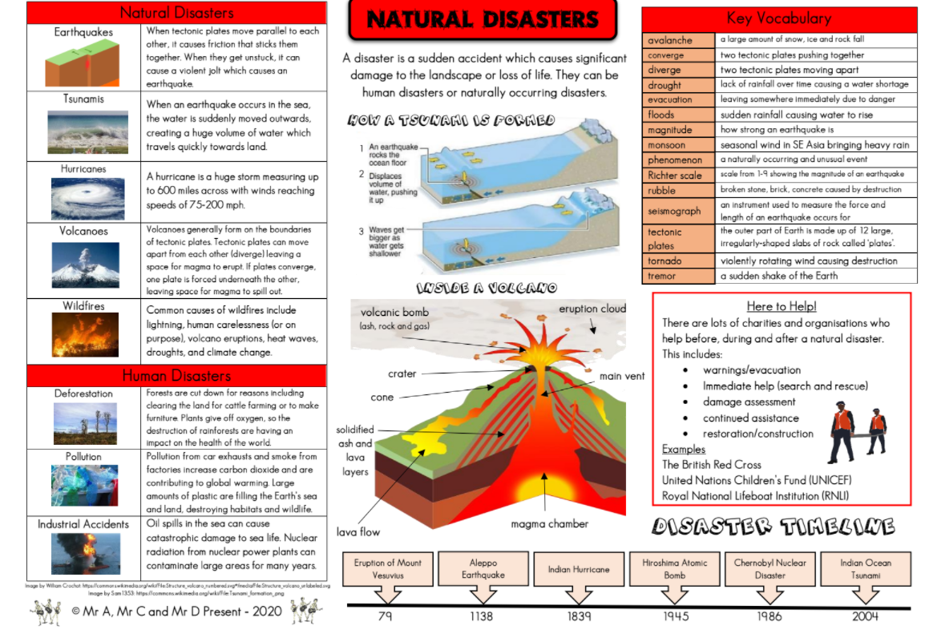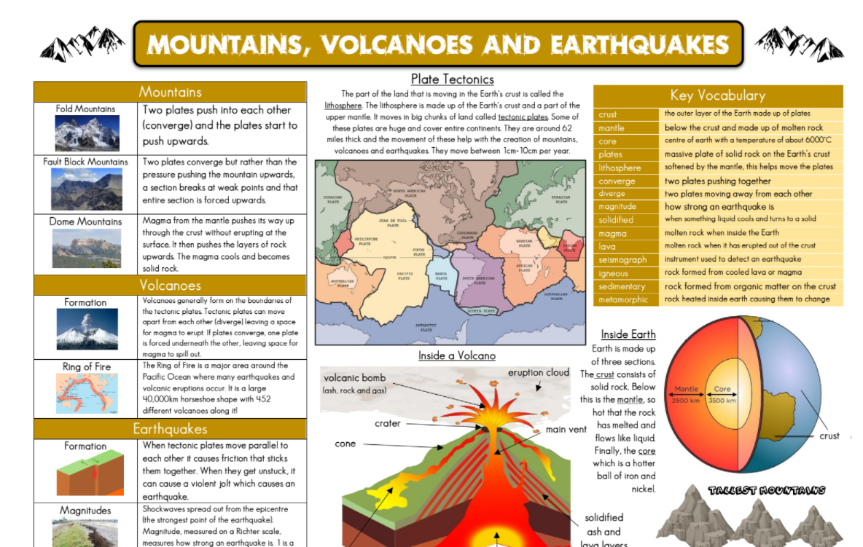 | Assessment:  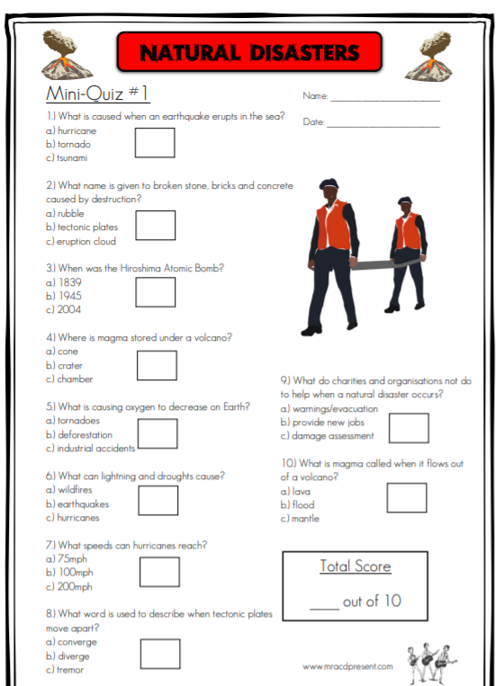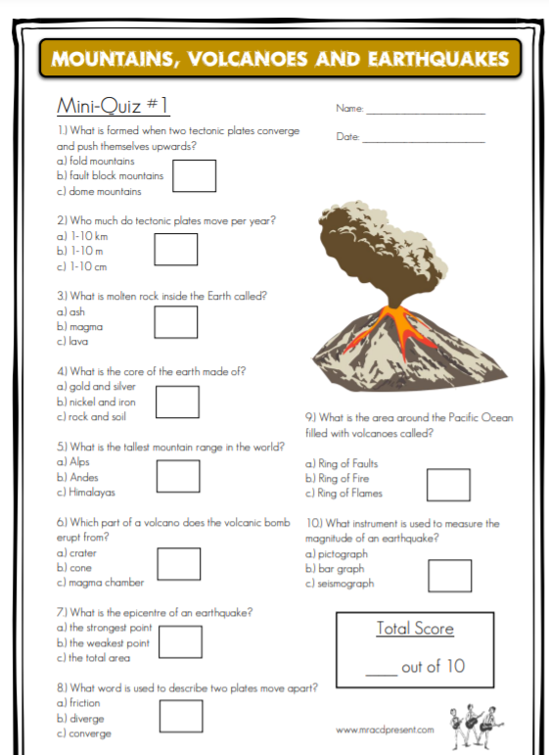

New vocabulary:
avalanche, tectonic plates, drought, evacuation, floods, magnitude, monsoon, phenomenon, Richter scale, destruction, seismograph, tornado, earthquakes, parallel, tsunamis, hurricanes, volcanoes, boundaries, magma, erupt, converge, wildfires, eruptions, heat waves, droughts, climate change, volcanic bomb, ash, rock, gas, solidified, lava layers, significant, damage, warnings, damage assessment, restoration, construction, crust, mantle, molten rock, tremor, plates, liquid, lava, eruptions, igneous rock, sedimentary rock, metamorphic, Ring of Fire, shockwaves.

Knowledge:
Describe and understand key aspects of: physical geography, including: climate zones, volcanoes and earthquakes.

Focus 1:
Natural disasters
What are natural disasters?
What’s the difference between natural and human disasters?
What is the earth made of?

Focus 2:
Volcanoes
How are volcanoes made?
Where in the world are volcanoes?
What happens when a volcano erupts?
How do volcanoes affect people’s lives?
Are all volcanoes dangerous?
The eruption of Vesuvius in Pompeii

FOCUS 3:
Earthquakes
How does an earthquake occur?
What happens when an earthquake occurs?
How are earthquakes measured?
What is it like living in an earthquake zone?
How can we protect against earthquakes?

FOCUS 4:
Tsunamis
What is a tsunami?
How are tsunamis formed?
What causes tsunamis?

FOCUS 5:
Why and how do people around the world prepare for emergencies?
What is an emergency?
How can people be better prepared for an emergency in the home or at school?
What makes a situation serious or unsafe?
How do charities prepare for disasters?

ART:
Inspired by our topic – Natural Disasters
In Art lessons, the children will use their sketch books to explore their ideas, produce creative work and record their experiences. The children will discuss and explore volcanic artwork inspired by the work of artist Margaret Godfrey. Then the children will recreate their own piece of artwork in the style of Margaret Godfrey. This will help build their understanding of the structure of a volcano through creation of layered artwork.
National Curriculum:
- to create sketch books to record their observations and use them to review and revisit ideas
- to improve their mastery of art and design techniques, including drawing, painting and sculpture with a range of materials [for example, pencil, charcoal, paint, clay
- about great artists, architects and designers in history

